LINK TO COMMONWEALTH WAR GRAVES COMMISSION (C.W.G.C.)

[Rifleman Victor H. Young | War Casualty Details 912441 | CWGC](https://www.cwgc.org/find-records/find-war-dead/casualty-details/912441/victor-h-young/)

The research on Victor Harry Young was carried out by the late Sue Tressler. He was not one of the original Felpham’s Fallen chosen for research, but his name is on his parents’ grave-marker in St. Mary’s

church-yard so he was included.

**The Menin Gate Memorial, Ypres, Belgium**

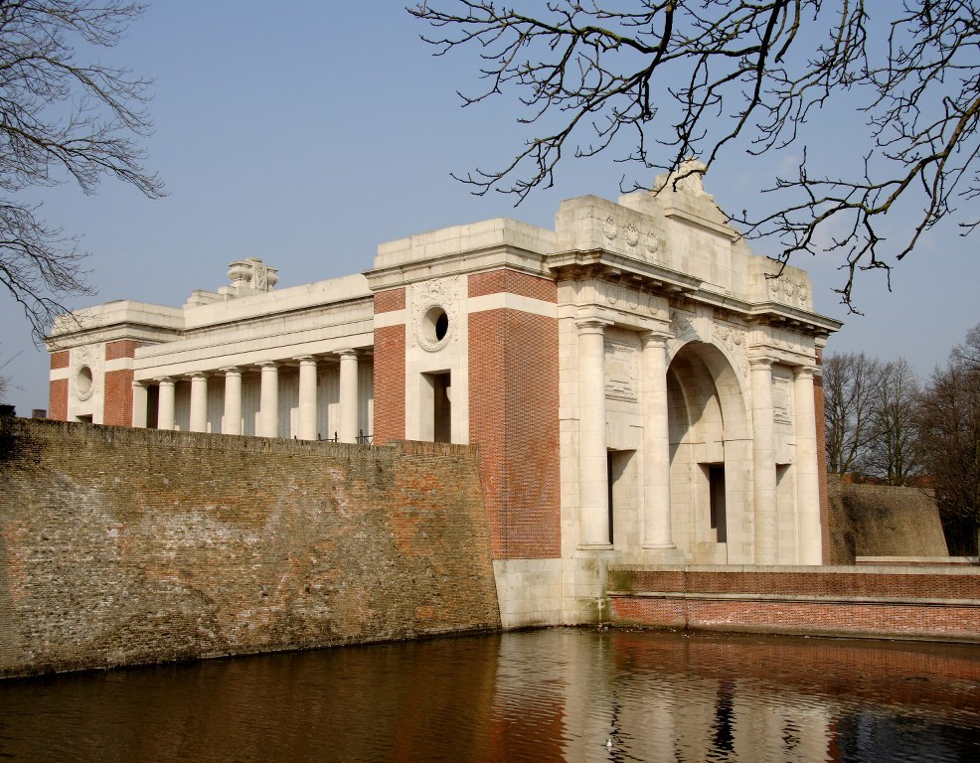

The 1901 census shows Victor H Young, age 6, living at 96 Victoria Road, Willesden Middlesex with his parents, Harry & Mary Ann, sister Christine Gladys and brother Harold Dudley. Victor was born in Chiswick. His father was an Inspector with the Gas. Light & Coke Company.

**1901 census**

By 1911 Victor was a Clerk working for the Gas. Light & Coke Company and living at 34 Mulgrade Road, Dollis Hill, Neasden, by this time there was a third son Joseph William.

**1911 census**

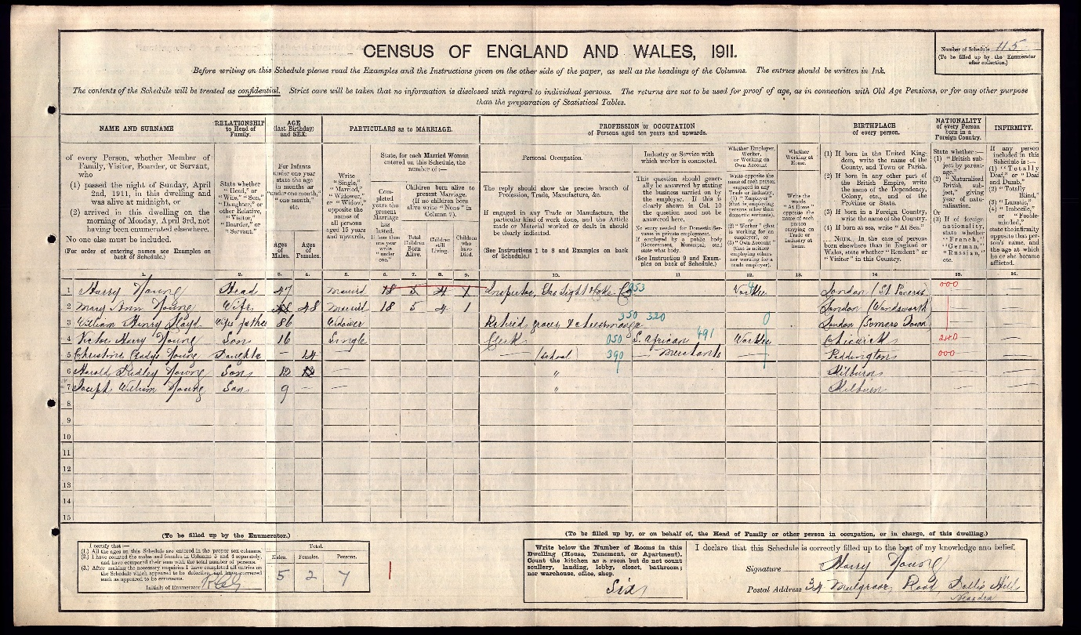

Victor volunteered at Neasden and was assigned the army rank and number Rifleman 1558 of the Queen Victoria’s Rifles. This battalion had a long history, it was an original volunteer force fighting in the Napoleonic wars.

By 1908 it had become a Territorial Army Battalion with the official title of the 9th (County of London), Battalion, London Regiment (Queen Victoria’s Rifles), known almost universally as the QVR’s. When the call came for the British Army to mobilise on 4th August 1914 the QVR’s were at their annual summer training camp at Crowborough in Esat Sussex.

Ten thousand men served in the QVR’s from August 1914 to November 1919. At this time it was acknowledged by the military leaders that without the Territorials it would have been impossible to hold the lines in France and Belgium and the Germans would have reached the Channel.

The QVR’s or the “Fighting Cockneys” as they were called arrived in France in November 1914. They were one of the first Territorial battalions to arrive in France and the first Territorial regiment to win a V.C. 1914 was stated to be the wettest on record.

Their first casualty occurred in the trenches in December. A and C companies played football on Boxing Day, despite the fact that the men were “sinking (in the mud) up to their thighs” in the trenches.

The men were already suffering from what became known as “Trench Foot”, it was noted that “The men’s feet…after being in the trenches all swollen up and it is awfully hard for them to get their boots on again if they take them off…”

The Battalion suffered away from the trenches. Their Headquarters were shelled resulting in death and wounding, with several men losing lower limbs. Individuals showed courage in helping the wounded. Corporal Brown who unfortunately, later died was helped to hospital by Rifleman Clevely. Both men had previously worked for the London and Smith’s bank in London. Later, men with such close connections were recruited as official policy into Pal’s Battalions” with horrendous results for towns, villages and workplaces losing a whole generation of their young men.

The QVR’s were bombed by a Zeppelin, however, most of the men were worried that the “football ground” would “become a crater” but luckily no bomb dropped on the pitch. Much worse was to come.

The battle of Ypres and the fight for Hill 60 occurred during April 1915. The hill had been made by spoil created by a new railway line installed to move goods back and forth to the front line. The hill was mined. On April 17th at 7 p.m. the mines were “fired” creating what was described as “an earthquake”. At this time the QVR’s were in rest billets 5 miles away. German reinforcements poured in and fighting continued all through the night and all of the following day, by 6 p.m. on the 18th the Germans ha succeeded in recovering part of the southern edge of the hill…The Germans were fired on with heavy artillery followed by close hand-to-hand combat with bayonets. At 2 p.m. the next day the Germans unleashed gas onto the troops.

[Hill 60 - World War One Battlefields (ww1battlefields.co.uk)](https://www.ww1battlefields.co.uk/flanders/hill-60/)

On Thursday 22nd April the QVR’s had moved under heavy fire to the railway cutting, “An aviator reported that a yellow…white…greenish yellow cloud higher than a man” could be seen. This was chlorine gas. The QVR’s had no equipment for gas attacks. They marched to a canal bank and slept there for the night. They moved to the trenches “…from the 23rd to the 25th the Regiment was involved “…in very heavy fighting…2 Officers wounded 21 (Riflemen) killed 76…wounded…5…missing 6 died of wounds, on the 26th the Battalion was relieved…” Captain Culme Seymour’s diary notes “…it’s been a big fight … we’ve been right in it and it really was awful…our machine gun sections… only 5 men and no guns left we have only got 200 men altogether left… we should have done and be doing much better if it wasn’t for those beastly gases… they have issued us with cloths now to pit over one’s nose and mouth …you have to damp them first…”. During the battle the QVR’s watched in horror as a bomb caused a huge fire wiping out a Canadian battalion.

Corporal Harold Sendall recalled the first day in the trenches as “the worst of the lot…the Germans…sent over some ‘Jack Johnsons’ *(A large German shell giving off dark smoke)* with a view to make you run then comes shrapnel to catch you as you run

Rifleman Sidney Seymour, in civilian lie a “well known…North London footballer…and an entertainer at Enfield Club Concerts” wrote “”…we only had rifles and bandoliers (a shoulder belt for cartridges) but… had to get on with it we went up to the front right into the thick of things… the trench filled with dead and wounded, bullets firing across, shells bursting, grenades and trench mortars…so effective were we… they gave up attacking and back they went… a bad day for us at the company roll call… the strain wa awful and to see your pals go one by one adds to the horror we cried like children and were completely broken up…were in it again the day after…” It was during this period that Rifleman Victor Harry young was killed in action at the age of 20. He is commemorated at the Menin Gate, Ypres, Belgium, as his grave is in an unknown place.

Of the ten thousand men of the QVR’s by 1919, 76 Officers died, 1385 menwere killed in action, 737 were transferred to other battalions “…making the total death toll of 1,552 (c. 5.5%).

A monument was erected by the survivors of the QVR’s on Hill 60 but this was destroyed by the Germans during the Second World War, a smaller monument remains there.

**de Ruvigny’s Roll of Honour**

YOUNG, Victor Harry, Rifleman No. 1558, 9th Battn., (Queen Victoria’s Rifles) The London Regt., (T.F.) s. of Harry Young, of 34, Mulgrave Road, Neasden, N.W., by his wife Mary A., dau. of W.H. Lloyd b. Gunnersbury, 19 Jan.1895; educ. Askes, Haberdashers, Hampstead Schools; was a Staff Clerk in the office of the Gas, Light & Coke Co. joined the Queen Victorias Rifles in 1912; volunteered for foreign service on the outbreak of war in Aug.1914; went to France, 2 Nov. and was killed in action at the Second Battle of Ypres, 23rd April 1915; ?; Buried there. *(Shown at right hand column bottom of page)*

**Index to Ypres Menin Gate Memorial**

His name is centred on the 13th row

**Index to Ypres Menin Gate Memorial**

YOUNG, Rfn.Victor H.1558, 1st Bn.Queen Victoria’s Rifles. 23rd April, 1915,

Column two item 4

**Register of Soldiers’ Effects**

Young Victor Harry 9th Bn.Lon Regt.(2VR) Rfman 1558 22.4.15 In action

£3.6.3 and £3 War Gratuity Fr Harry

**WW1 Medal Rolls Index card**

Victor was entitled to the 1914 Star with clasp and the Victory & British War medals.

*Some medals have a horizontal metal bar worn on the ribbon and inscribed '5th Aug.-22nd Nov. 1914', this distinguished those who had served under enemy fire.*

*This clasp was replaced by a small silver rosette when the ribbon was worn without the medal.* *There were approximately 378,000 1914 Stars issued.*

*(Imperial War Museum)*

**WW1 Service Medal & Award Rolls**

1558 Rfn. YOUNG Victor H. 9th Lond.R. Rfn. 1(a) 5.11.14. to 23.4.15 K.A, 23.4.15

**St. Mary’s churchyard, Felpham**

Royal British Legion

[Every One Remembered - Soldier Profile Victor h. Young](https://www.everyoneremembered.org/profiles/soldier/912441/)