LINK TO COMMONWEALTH WAR GRAVES COMMISSION (C.W.G.C.)

[Lance Corporal Cyril George Sparshott | War Casualty Details 471413 | CWGC](https://www.cwgc.org/find-records/find-war-dead/casualty-details/471413/cyril-george-sparshott/)

**Calais Southern Cemetery, France**

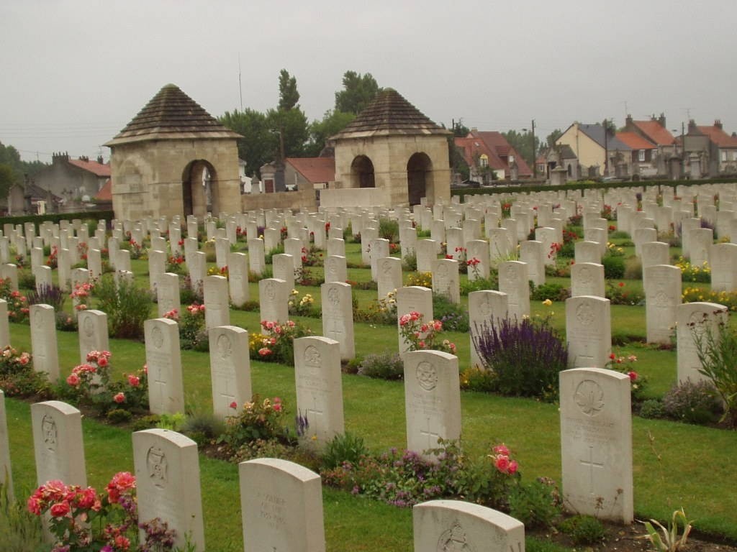

**Baptism of Cyril George Sparshott**

2nd December 1888 at Portfield, Chichester, father Joseph a carpenter, mother Eliza Kate, of Felpham. (Last entry)

**1891 census**

In 1891 the Sparshott family were living at Ithica Terrace. Joseph, Head, 37, a carpenter, Wife, Eliza K., 25, Cyril George, 2, and Florence K, 7 months.

Both children born in Felpham

**1901 census**

By 1901 they were living at The Mill (Amey’s Petersfield Ales & Stout at Snooks Corner). Joseph, 47, is now described as a Beer Retailer & Grocer, Carpenter Own Account. Eliza, 35, Cyril, 12, Florence, 10, and Bernard, 8, also born in Felpham

**1911 census**

Still at The Mill are, Joseph, 57, Off Licence Beer Dealer, & General Business. Wife Eliza Kate, 45. They have been married for 23 years, have had 6 children of whom 2 have died. Cyril George is 22 and a carpenter, Florence Kate, 20 & Bernard Joseph, 18, both assist in the business. Joseph Henry, born in Felpham is 4.

**Graves Registration Report Form**

Calais Southern Cemetery

Plot H, Row 2 (4th entry)

8 R.Sussex 8325 Sparshott L/c C.G. 6.8.17. ? Grave No. 4

**Index to Calais Southern Cemetery**

SPARSHOTT, Lce. Cpl. Cyril George 8325. “D” Coy. 8th Bn. Royal Sussex Regt. Died of wounds 6th Aug., 1917. Age 29. Son of Joseph and Eliza Kate Sparshott of Compton House, Golf Links Avenue, Felpham, nr. Bognor, Sussex.

Plot H. Row 2. Grave 4

(Left hand column, 7th entry)

**Imperial War Graves Commission**

1062/1C 8325 LANCE CPL

. CYRIL GEORGE SPARSHOTT ROYAL SUSSEX REGIMENT

6TH AUGUST 1917, CROSS, PLOT H, ROW 2, GRAVE 4, STONE 652

(last but one entry)

**Imperial War Graves Commission**

Headstone Personal Inscriptions

1062/1C 652 “AT REST HIS DUTY DONE”

(Joseph Sparshott Esq., Crompton House, Golf Links Avenue; Felpham, Nr. Bognor

(2nd entry)

Royal Sussex Regiment roll of individuals entitled to Victory and / or British medals.

G/8325 L/CPL., SPARSHOTT, Cyril George, G/8325 8th R.SUSS. R.

A / CORPORAL

(4th entry)

**Medal Rolls**

Sparshott, Cyril G., R.Suss, R, A(cting) Cpl., G/8325

Entitled to Victory & British war medals

**Register of Soldiers Effects**

545237 432773 Sparshott Cyril George 8 / Bn Royal Sussex Regiment L/Cpl G/8325

6.8.17 France H’slow, Fa Joseph £3 9s 8d War Gratuity £7 10s 0d

(2nd entry)

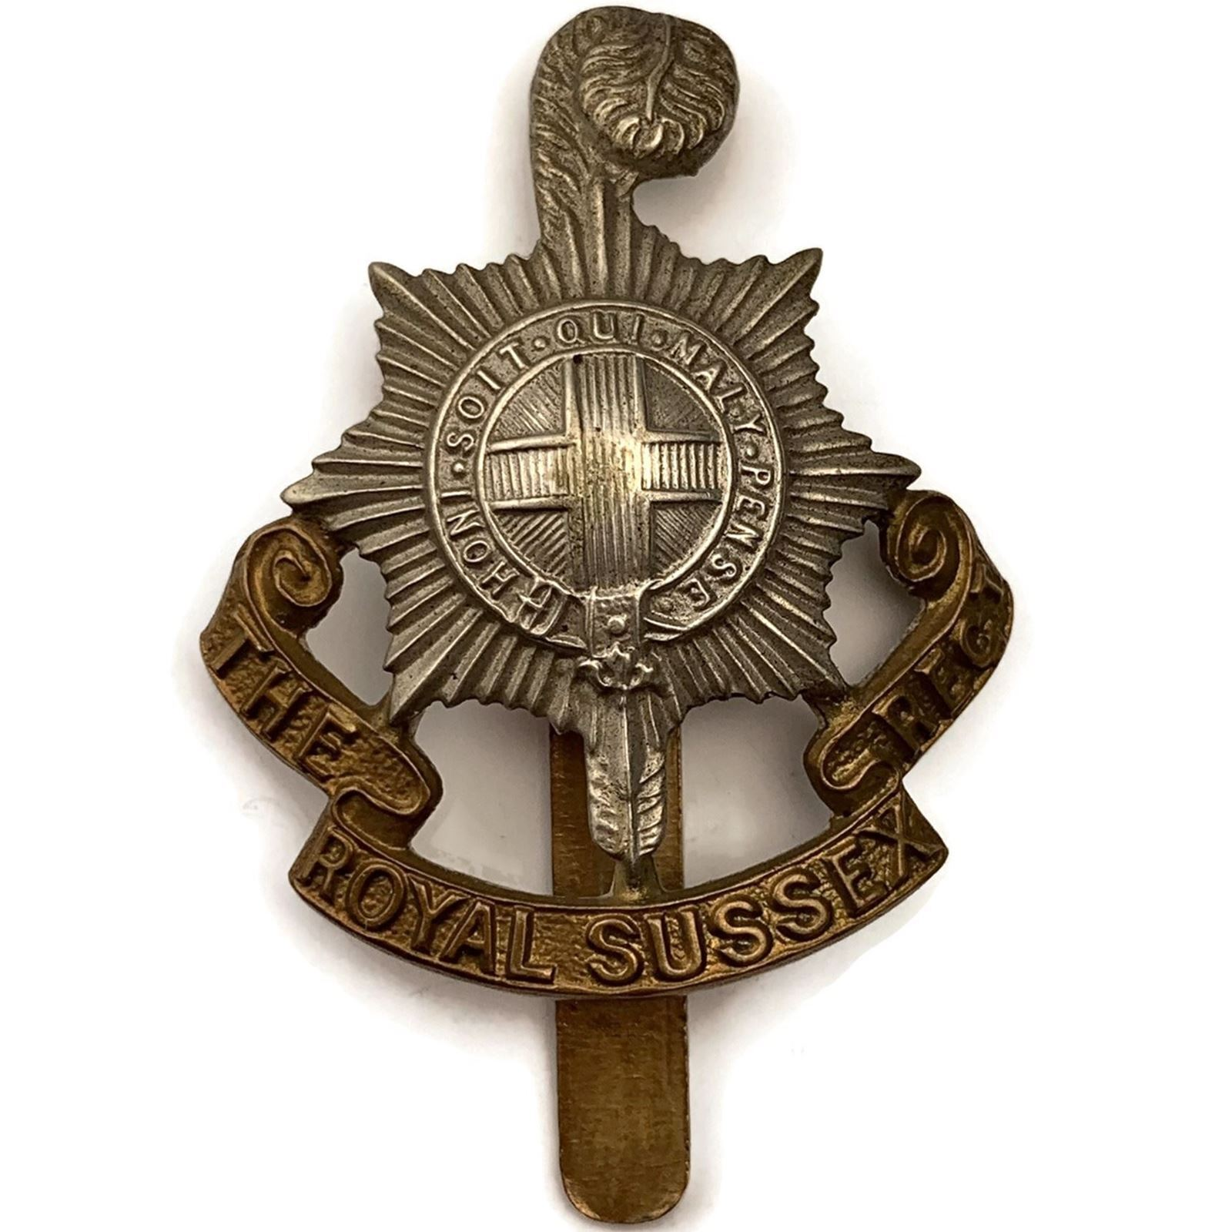

Royal British Legion

[Every One Remembered - Soldier Profile Cyril george Sparshott](https://www.everyoneremembered.org/profiles/soldier/471413/)