LINK TO COMMONWEALTH WAR GRAVES COMMISSION (C.W.G.C.)

<https://www.cwgc.org/find-records/find-war-dead/casualty-details/71530/arthur-henry-snook/>

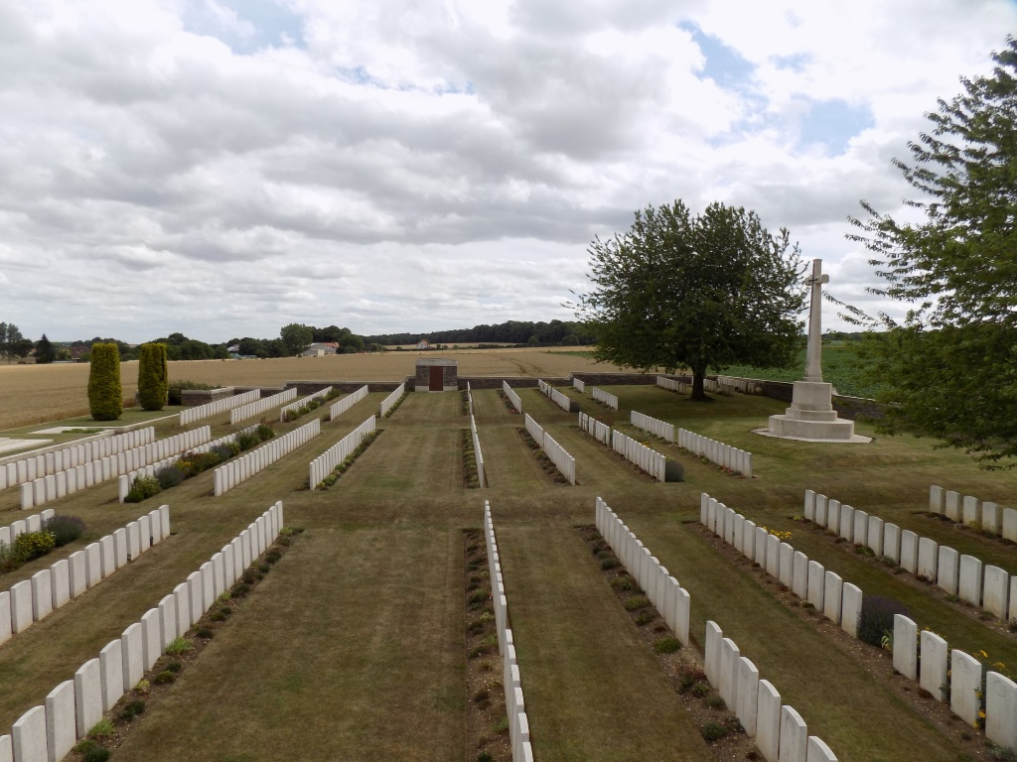

[crouy british cemetery - Search Images (bing.com)](https://www.bing.com/images/search?q=crouy+british+cemetery&qpvt=crouy+british+cemetery&form=IGRE&first=1)

**Baptism**

August 18th 1889 Arthur Henry son of Henry Thomas, Gardener, and Emma Snook of Abbey Street in the Parish of Farnham in the County of Surrey.

(Left hand page, last entry)

**1891 census**

The SNOOK family, Henry, 32, a Gardener, Emma, 30, sons Byron, 4, born Brighton and Arthur H, 1, born Farnham, Surrey, lived at No. 1 Lyon Street, South Bersted, Bognor

**1901 census**

By 1901 the family had moved to Victoria Cottages (the census reads as Cannon Road, possibly Canning Road)

**2nd April 1911 census**

In 1911 Arthur Henry was a patient at the West Sussex, East Hampshire and Chichester General Infirmary and Dispensary.

The Royal West Sussex Hospital was opened in 1826, although a public dispensary had been established in some cottages on the site of the hospital in 1784.

From 1826 until 1913 the hospital was known as the West Sussex, East Hampshire and Chichester General Infirmary and Dispensary. In 1913 a grant of King George V renamed the Infirmary to The Royal West Sussex Hospital. It continued to serve the public until 1972 when it was closed following the commissioning in Chichester of the new development of St. Richard's Hospital.

**(Source The National Archives)**

Marriage between Arthur Henry Snook, 22, and Gertrude Brown, 21, on December 17th 1911 at St. Mary’s Church Paddington, in the County of Middlesex.

The fathers were Henry Thomas Snook, gardener & Reuben Brown occupation unclear.

Baptism of Doris Snook, daughter of Arthur Henry & Emma Snook of 4 Gordon Terrace at St. Mary’s Church, Felpham, Easter Day 7th April 1912

(6th item)

**Information from The National Archives; Catalogue Reference WO95/456/1**

**War DIARY or INTELLIGENCE SUMMARY**

May 1918 86 Army Brigade; Villers Bretteneux

20/5/18 to 6/6/18 “Brigade in Action” (no other details)

**Crouy British Cemetery**

**Graves Registration Report Form**

86/Bde. RFA. 235556 Snook Gnr. A.H. 23.5.18 E. (Cross erected) Grave 18

(7th entry)

**Imperial War Graves Commission**

Comprehensive Report of Headstone Inscriptions

1186/2D 235556 GUNNER A.H.SNOOK ROYAL FIELD ARTILLERY

24TH MAY 1918 CROSS E (Plot) 2 (Row) C (Grave) 20 214

(7th entry)

**Imperial War Graves Commission**

Comprehensive Report of Headstone Personal Inscriptions

1186/2D 212 “TO DEAR ARTHUR FROM HIS SORROWING WIFE AND BABY”

(Mrs G. Snook, Victoria Cottage, Sea Road, Felpham, Nr. Bognor, Sussex)

(5th entry)

**Index to Crouy British Cemetery**

SNOOK, Gnr., Arthur Henry, 235556. 86th Bde., Royal Field Artillery. Died of wounds 23rd May, 1918. Age 28, Son of Henry Thomas and Emma Snook, of Felpham, nr. Bognor, Sussex. II.C.18

(Column 1 third entry)

**WW1 Medal Rolls Index card**

SNOOK Arthur H R.F.A. Gnr 235556 entitled to Vitory & British War medals

**Medal Index Roll showing indivoduals entitled to the**

**Victory medal and British War medal.**

23556 Gnr. SNOOK Arthur Henry R.F.A. 235556 Gnr.

(4th item)

Royal British Legion

[Every One Remembered - Soldier Profile Arthur henry Snook](https://www.everyoneremembered.org/profiles/soldier/71530/)