LINK TO COMMONWEALTH WAR GRAVES COMMISSION (C.W.G.C.)

<https://www.cwgc.org/find-records/find-war-dead/casualty-details/552093/archibald-fred-marsh/>

**Albert Communal Cemetery Extension, Somme, France**

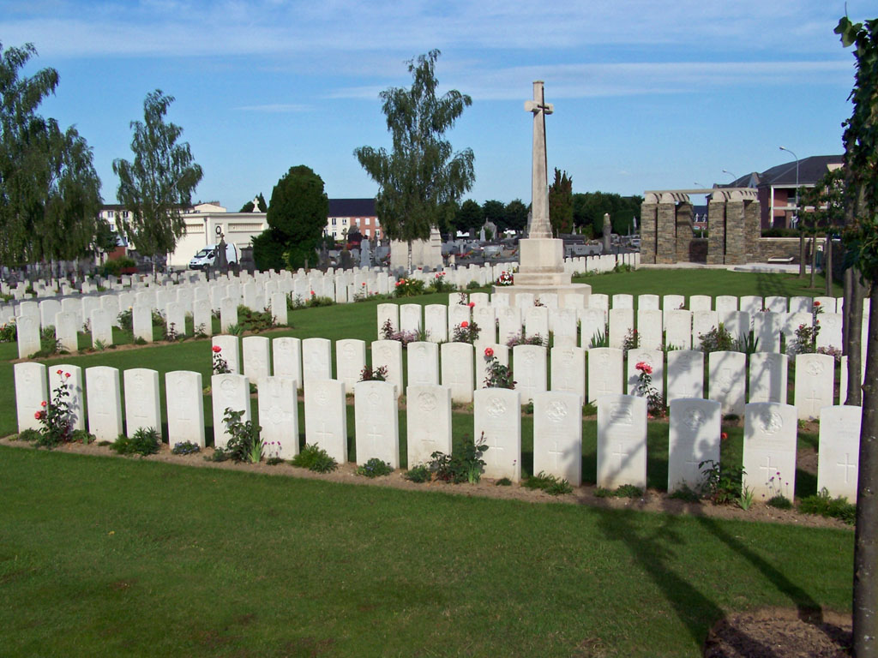

**Baptism** of Archibald Frederick Marsh, son of Mark & Annie, on 21st February 1900 in the Parish of Selsey, Sussex

(5th entry)

**1901 census**

The Marsh family, Head Mark, 42, a Foreman Navvy, Wife Annie 35, Ernest, 13, Nellie, 10, Harry, 7, Gladys, 4, Archibald, 1, born in Selsey, lived at 14, Manor Road, Selsey.

**1911 census**

By 1911 the family were living in a 5 roomed house at 52, Warehead, Halnaker, Sussex. Mark, 52, a Horseman on Farm, Annie Maria, 44, Gladys, 14, Archable (sic) Fred 11, Frank Lewis, 9, and Sarah Annie, 7.

In 1911 Mark and Annie had been married for 23 years and had 8 children one of whom had died,

An Ernest Edward Marsh was serving with the Royal Artillery In Port Royal, Jamaica

**7th Battalion The Buffs (East Kent Regiment), War Diary for 22nd Auguat 1918 is on The National Archives website at WO-95-2049-1_04 (1) pdf but is mostly unreadable.**

**GRAVES REGISTRATION REPORT FORM**

ALBERT COMMUNAL CEMETERY EXTENSION

PLOT 2 ROW “D”

7TH Buffs (Shown as 14458, actual was 14457) MARSH PTE. A.F. 27.8.18 (Grave) 6

(Last entry)

**IIMPERIAL WAR GRAVES COMMISSION**

1027/10 G/14457 PRIVATE A.F. MARSH. E. KENT. (THE BUFFS)

22nd AUGUST 1918 AGE 18 CROSS (PLOT) 2, (ROW) D (GRAVE) 6

(3rd entry)

**IIMPERIAL WAR GRAVES COMMISSION**

HEADSTONE PERSONAL INSCRIPTIONS

1027/1C 835

HE DIED THAT WE MIGHT LIVE PEACE PERFECT PEACE

(Mrs. A.M.Marsh, 3, East View Cottages, Limmer Lane, Felpham, Bognor.)

**WW1 MEDAL ROLLS INDEX CARD**

Archibald Frederick was entitled to the Victory & British War medals.

**INDEX TO ALBERT COMMUNAL CEMETERY EXTENSION**

MARSH, Pte. Archibald Fred, G/14457. 7th Bn. The Buffs.

Killed in action 22nd Aug. 1918. Age 18.

Son of Mark and Annie Maria Marsh of 3, East View Cottages, Limmer Lane, Felpham, Bognor, Sussex. II D 6

(7th entry left hand column)

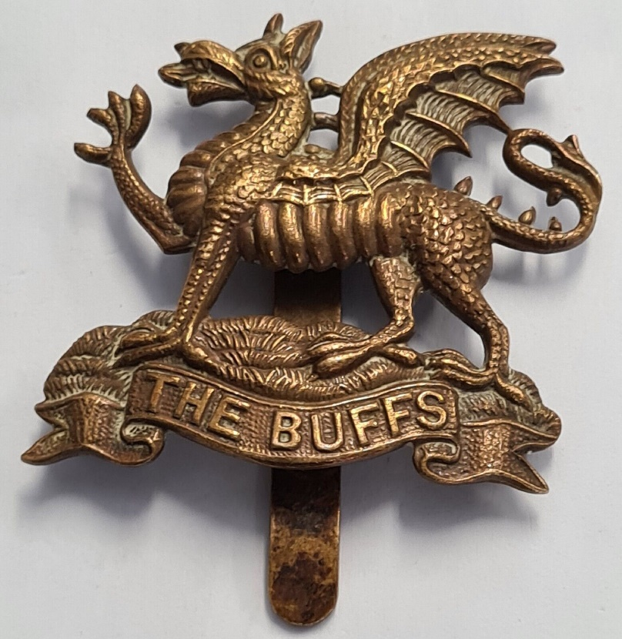

**Royal British Legion**

[Every One Remembered - Soldier Profile Archibald fred Marsh](https://www.everyoneremembered.org/profiles/soldier/552093/)