The Felpham and Middleton
War Memorials.

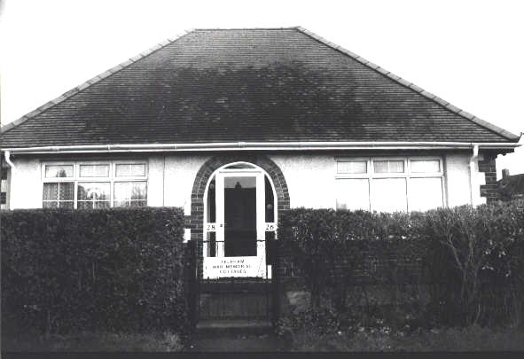

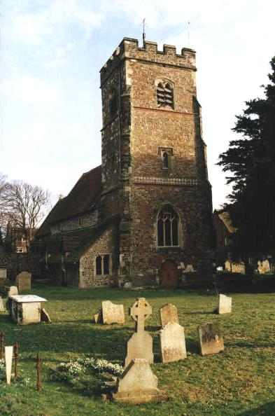

R.H.Brooks

September 2001
Contents

1 Introduction.

2 “An Unusual War Memorial” by Gerard Young, “The Post” November 14, 1970.

3 The Felpham and Middleton War Memorial Cottages.

4 St. Mary the Virgin War Memorial to the Great War.

5 St. Mary the Virgin War Memorial to the Second World War.

6 St. Mary the Virgin Second World War burials not included on the church memorial.

7 Other Second World War casualties.
Introduction.

For a good many years I walked past the cottages in Flansham Lane and wondered about the men whose names were inscribed on the plaque in the porch between the pair of cottages and also about the cottages themselves.

In 1999 an article in the “Family Tree Magazine” referred to the National Inventory of War Memorials and I decided to find out both about the men and the cottages.

These pages then are a record of those men of Felpham and Middleton who did not return home from the two World Wars and whose names are commemorated in the Parish Church of St. Mary the Virgin or on the plaque in the pair of cottages built by public subscription in their memory or who may not be recorded in either place but who paid the supreme sacrifice.

The Imperial War Museum had, for about the last ten years, been collecting data for a National Inventory of War Memorials. As of late 1999 the Museum was not aware of the existence of the cottages in Flansham Lane known locally as the Felpham War Memorial Cottages or of the memorials in St. Mary’s.

The cottages were, and still are, let to poor ex-servicemen or to their descendants and are in the hands of Trustees whom I should like to thank for allowing me to photograph both the cottages and the plaque. I should also like to thank one of the current residents for showing me round her cottage.

In 1970 a local historian, Gerard Young, wrote an article in the local newspaper, The Post, as to how the building of the cottages was organised and the funds raised.

I had not originally considered the memorials in St. Mary’s church in Felpham village but did so after meeting a local historian Sheila Gould.

To date some details of 38 of the total of 41 men whose names appear on the two Great War memorials have been found.
They were found either on the Commonwealth War Graves Commission website or The Soldiers Died In The Great War CD-ROM.

Those not yet found are Charles J. JONES; Frank J. JONES; Harry FULLER.
The names of two men, Harry Fuller R.N. and Peter Fuller R.S.R., do not appear on the Great War plaque in St. Mary's church.
Two names, those of John Keith Clothier and John Verity Poole, do not appear on the Felpham and Middleton War Memorial Cottages plaque.

The private memorials within the church have not yet been investigated.

Details of the Felpham and Middleton War Memorial cottages, together with photographs of the cottages, the plaque and a transcript of the Post article, were sent to the Imperial War Museum on 19th January 2001.
“An Unusual War Memorial” by Gerard Young, The Post November 14, 1970.

THE POST, Saturday, November 14, 1970.

GERARD YOUNG

An unusual War Memorial

EASTERGATE'S WAR MEMORIAL is seen by thousands, Bognor’s does not go unnoticed, but where is Felpham’s?

Not many people could say, because the Felpham memorial to the fallen is put to the use of the living. It is no cenotaph or statue, but two semi-detached cottages next to the Post Office in Flansham Lane. Within the porch is a tablet inscribed with the names of the dead.

Since this is the Golden Jubilee year of the building of the cottages and because the Trustees (it is Felpham’s only charity) wish to raise funds to add bathrooms, here are a few details of how it all began.
Five months after the end of the 1914-18 War, a committee meeting was held in the Parish Room, a thatched building next to the Fox, on a corner of Vicarage Lane (a flower bed now marks the site).
Out of several suggestions for a fitting Memorial, one was for an alms-house which in turn led to the idea of a cottage. One of the enthusiasts for this was Mr. W. J. Flexman, a builder who had come from Ealing in about 1909 and developed some of the Sea Road area in Felpham. He was to become Hon. Clerk of the Works for the project. His proposal was seconded by Mrs. May.

Suggestions.

Other suggestions included one for a parish hall, for which the land was offered free, but the total cost of about £2,000 was considered beyond local resources and so the land went to the Vicar for a hall, now in Limmer Lane.
Following this meeting, on May 8 1919, one was held for the parish on July 14 and the scheme for cottage, or a pair if funds permitted, was approved as being the "most suitable and practical memorial".
The site in a field in Flansham Lane had been given by Mr. Robert Sadler, of Church Farm, Felpham. His farmhouse is now Church House and some of his land extended along the shore, now built over as Felpham Beach Estate. Summerley Barn was among his farm buildings.
Mr. Sadler was Hon. Treasurer and fund-raising started at once. A leaflet was circulated in which the parish was reminded:

The War has, by the mercy of God, and by means of innumerable acts of heroism on the part of our sailors, soldiers and airmen, been brought to a conclusion such as we hardly dared to expect. A large number of men from Felpham have laid down their lives for our protection.

The proposed cottage was to cost about £500. The leaflet bore the names of those who promised donations. These ranged from two guineas from Mr. G. Bicknell, a fisherman, to £100 from a city man, Mr. H. Blunt, at Flansham House. A subscription card was printed and left at houses and shops, so that residents could respond and fill in an amount and give it to the collectors when they called.
The response during the ensuing year was good and donations amounted to £694.10s.1d. To this was added a further £30 from Farmer Sadler who, by some legality, had to sell the Trustees the land for £30. On receiving it, he gave the money back to them.
The Trustees of what was to be known as the War Memorial Charity included Mr. Flaxman, Mr. Sadler and another farmer, Mr. John Langmead, of Northwood, Yapton.
There was also Mr. George Tate, the coal merchant who, from 1920-32, was to operate the Red Rover single-decker bus service from Felpham to Pagham. His bus shed still exists in Havelock Close.
The landlord of The Fox, Mr. Thomas Arthur Richardson, had been in the building trade and helped to erect The Arcade in Bognor. He had been licensee of the King’s Head, Steyne Street, and took over The Fox in 1908, because he liked the inn’s pretty garden. His skill as a bricklayer was made available to his co-trustees and he helped to build the Memorial cottage.
Other Trustees were Mrs. Amy Knight who. I believe, was the wife of blacksmith George Knight, Miss Kate Scott, whose family had run the Old Bakery in Felpham Way since 1804 (it was demolished, regrettably, in 1966), Mr. Fred Aylward, the Waterloo Road grocer, who was president and a director of the Hotham Bowling Club and, in his younger days, a teacher of dancing.
The Trust’s Secretary was a retired butler, Mr. David Newell, of Sea Road. Another trustee was the coal merchant and carrier, Mr.James Hale, who was a leading light in the running of the nonconformist chapel in Flansham Lane (now Whitlock, builders) and had a notice on his house: "Carrier to Chichester on Tuesdays and Thursdays, D.V. On Saturdays, D.V. or not". Mr. Hale, a parish councillor and school manager lived at The Sycamores, now the cycle shop which was run by the late Mr. W. J. Richardson who married his grand-daughter.
Finally there were the local plumber, Mr. Henry Alfred Witcher, of the Nutshell, Flansham Lane, and the butcher, Mr. Frederick Thomas Ruff.
Mr. Ruff, who was born at Shripney in 1886, had his first shop next to The Sycamores before moving to the Snook’s Corner end of the village. Age does not appear to have had any effect on Mr. Ruff, who is the only surviving member of the original body of trustees and is chairman.
His associates today are Mr. F .A. Aylward (son of Mr. F. H. Aylward), Mr. P. H. Bailey, Mr. D. A. N. James, Mrs. D. V. Curteis, Mr. W. H. T. Cunningham, Mrs. B. W. Cunningham, Mr. W. L. Stentiford, and Mr. W. P. Bellingham (hon secretary and treasurer).

Deed of Trust.

Back then, to 1920. The War Memorial cottage had now become two, under one roof, on a site 65 ft. * 120 ft. They contained a living room, bedroom and kitchen and the memorial tablet was installed in the communal porch. The deed of trust enabled the trustees to let the cottages to:

“Inhabitants of the parish of Felpham who, through poverty or misfortune, are in need of assistance, but so that, if all other things are equal, a preference shall be given to men who fought in the Great War and were , at the time of joining any of His Majesty’s Forces, living in the said parish and to the dependants of such men".

The work was eventually finished and the cottages were ready. It had been a splendid achievement by Felpham people. Altogether, £737. 13s. 8d. had been raised.
The cost of the building was £517. 17s. Other items were; fencing, £9 14s. 11d.: shrubs, £1. 10s. ; making up the gardens, £5. 3s.; cleaning the cottages, 17s.; memorial tablet, £25. 16s.
To provide an endowment fund to maintain the property, £150 was invested.
There is no record of how the first tenants were selected, but the first name in the rent book (1s. a year) is that of Mrs. Ashcroft, in 1922. Mrs. George and Mrs. Fuller followed in 1923.
There have only been about 10 occupiers since the beginning- "All wonderful tenants" the chairman told me- and they paid 1d. a month until 1964, the year that Bognor Regis Council first levied rates against the Charity. The tenants now pay the rates.
Mrs. Ellen Smith has lived there since 1942 and her neighbour Miss Ann Staker who has been there for four years and was preceded by her mother and her sister. Her father was carter to Mr. Robert Sadler and looked after a team of horses at Summerley Barn.
When a vacancy occurs at either of these cottages, the Trust has to announce this by advertisement. The last occasion was in 1966 when they had seven applicants to consider.
Well, as I said the beginning, this is the golden jubilee and the Trust would like to mark the 50 years by raising enough money to build bathrooms.
Their investment income from Government stock amounts to about £12 a year, which isn’t much to keep the cottages in their existing good condition. If, with public help, they can raise £400, they will become eligible for another £400 under the Improvement Grant scheme.
It will be quite a task to find £400. However, the trustees have something of the old spirit of that parish hall meeting of 1919. The cottages are still a memorial to local men.
If you feel like making their task easier, send a donation to the War Memorial Cottages fund, c/o Barclays’ Bank, Bognor. or to the Trust treasurer, Mr. W. P. Bellingham, "Winton", Summerley Lane, Felpham."
The Felpham and Middleton War Memorial Cottages.
The cottages lie on the eastern side of the A259, Flansham Lane, some 200 yards north of the roundabout by the Southdowns Public House.

The dedication on the plaque in the cottages reads:-

1920
FELPHAM AND MIDDLETON WAR MEMORIAL COTTAGES
ERECTED BY THE PARISHIONERS IN MEMORY OF THE MEN OF THESE
PARISHES, WHO LAID DOWN THEIR LIVES IN THE GREAT WAR.
1914 - 1918

"THEIR NAME LIVETH FOR EVERMORE"
St. Mary the Virgin War Memorial to the Great War.

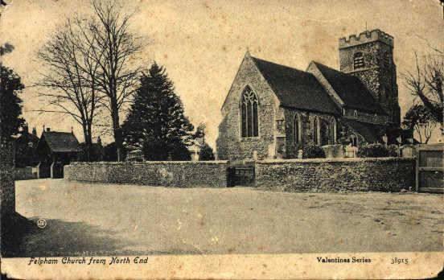

The dedication on the Great War plaque in the Church reads:-
TO THE GLORY OF GOD
AND IN UNDYING MEMORY OF
THE MEN OF THE PARISHES OF
FELPHAM AND MIDDLETON
WHO GAVE THEIR LIVES FOR
KING AND COUNTRY
DURING THE WAR 1914 - 1918

In tuas manus Domine

* Although a member of the Royal Sussex Regiment J. Marchant's headstone shows Royal Air Force insignia.

** To date the grave of Frederick G. Pay has not been found although apparently in St. Mary's churchyard.
St. Mary the Virgin War Memorial to the Second World War.

Thirty two men are commemorated on the Second World War church plaque. Details of 28 have been found to date, those not yet found are H.J.CHILCOTT; D.FLORY; A.STUART; J.A.WILLIAMSON.

The dedication on the plaque in the Church for those who died during the Second World War reads:-
1939 - 1945

WE WILL REMEMBER THEM

At least nine of the 28 were officers, compared to none of the 38 men of the Great War about whom some details are known. Why should there have been such a difference ?

Interesting to note that no memorial such as the Cottages was raised to the men who died during the Second World War; that neither of the Church plaques give any details of the Service in which the men served and that no Christian names are shown for those who died during the Second World War.

St. Mary the Virgin Second World War burials not included on the church memorial.

There are eight Second World War burials in St. Mary's churchyard which, for reasons not yet known have not been included on the Second World War plaque within the church. At least six of these burials appear to have some connection with either Felpham or Bognor Regis.

Other Second World War casualties.

A number of other Second World War casualties with Felpham connections, recorded either in the Bognor Post, on the Bognor Memorial or elsewhere, have also not been recorded on the church plaque.

