LINK TO COMMONWEALTH WAR GRAVES COMMISSION (C.W.G.C.)
Private G Bridger | War Casualty Details 444952 | CWGC

G BRIDGER’S Gravemarker, Ration Farm Annexe (La Plus Douve), Belgium

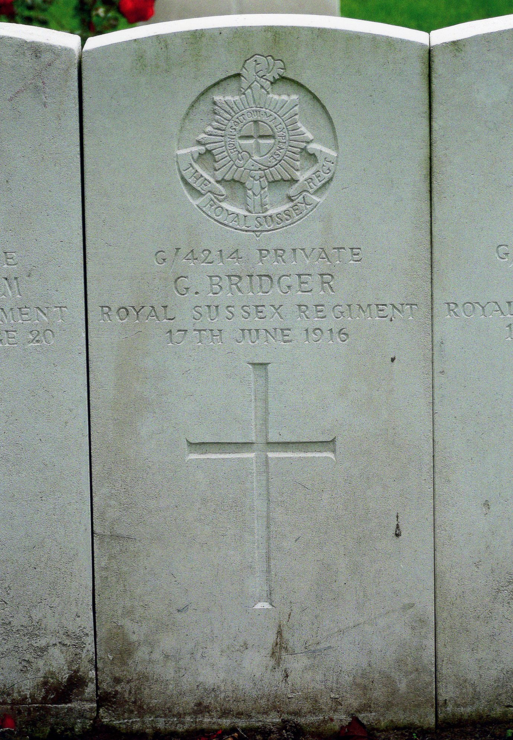
(Source:-The War Graves Photographic Project in association with the
Commonwealth War Graves Commission)

The 1901 census has not yet been found.

The 1911 census for Slindon shows George BRIDGER, Head of the family aged 43, married, working as a Carter on a farm, and that he was born in Yapton, Sussex;
His wife was Edith Bridger, age 43, they had been married for 22 years 7 months 7 days, she was born in Landport Hants,
In 1911 they had had seven children, two of them were no longer at home. Those at home were George aged 16 an Assistant Carter on a farm born in East Grinstead Sussex. There were three daughters; Dulcie 13 & Mabel 9 both at school and both born in Woking Surrey also Ettie aged 3 born in Slindon, Sussex and son Cecil 1 also born Slindon. They were all living at 66 Court Hill Slindon, Arundel

1911 census

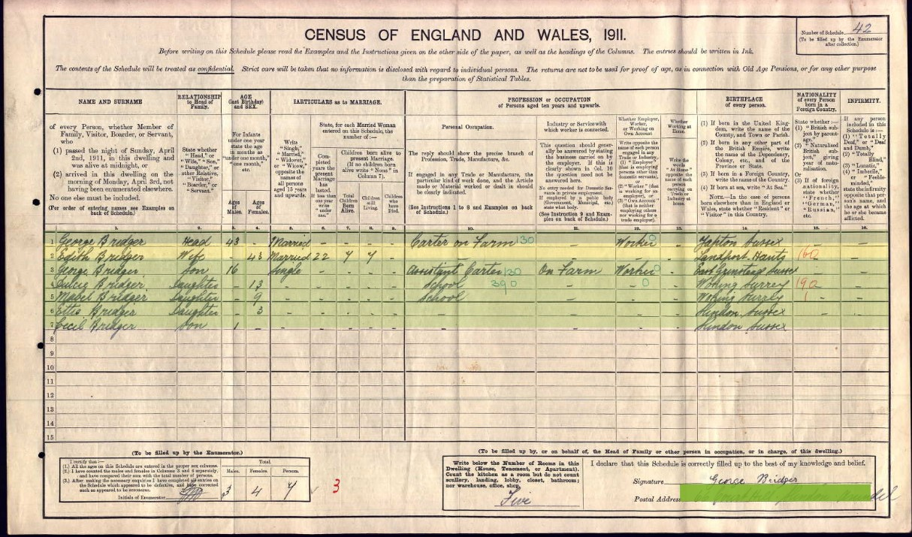

By 1912 the family had moved to Felpham.

The electoral roll for the parish of Felpham in 1912 shows George & Edith BRIDGER at Innerwhyke Cottage. The Felpham rate book for 1912 shows George BRIDGER at Cottage & garden (next to Summerley cottages).

The Commonwealth War Graves Commission shows him as G. BRIDGER, son of Mrs E. BRIDGER of 4 Manor Cottages Felpham.
St Wilfred's Bognor memorial show him as George William age 21, father the late George BRIDGER, mother Edith Harriett PHILLIPS.
The Felpham Roll of Honour shows him as George William, son of Mr & Mrs E BRIDGER, born in East Grinstead, enlisted Chichester.
The National Archives record card shows him as John, q.v.
Each of the above references show him as being G/4214 Private, in the 9th Battalion the Royal Sussex Regiment, so there's not much doubt that we are talking about the same man but why are there these differences.
Date of Entry into Theatre 31.8.15
9th (Service) Battalion Royal Sussex Regiment (During WW2 the 9th were known as the "Shiny Ninth" but I have been unable to establish why).
https://www.forces-war-records.co.uk/units/2022/royal-sussex-regiment/
Sept 1914 Formed at Chichester as part of the Third New Army (K3) and then moved to South Downs to join the 73rd Brigade of the 24th Division.
Dec 1914 Moved to Portslade and then to Shoreham and on to Woking.
01.09.1915 Mobilised for war and landed at Boulogne and the Division engaged in various actions on the Western Front including;
1915 The Battle of Loos
1916 The German gas attack at Wulverghem, The Battle of Delville Wood, The Battle of Guillemont.
The Gas attacks at Wulverghem in the municipality of Heuvelland were two German cloud gas attacks during World War I on British troops near Ypres in the Belgian province of West Flanders. The first gas discharge was on 30 April 1916 and on 17 June was followed by another. The gas attacks at Wulverghem were part of the sporadic fighting, which took place between battles in the Ypres Salient on the Western Front. The British Second Army held the ground from Messines Ridge north to Steenstraat. British divisions opposite the German XXIII Reserve Corps, had received warnings of a gas attack in the ten days beforehand. From 21–23 April, British artillery-fire exploded several gas cylinders in the German lines around Spanbroekmolen, which released greenish-yellow clouds of gas. A gas alert was given on 25 April, when the wind began to blow from the north-east and routine work was suspended; on 29 April, two German soldiers deserted and warned that an attack was imminent. Just after midnight

on 30 April, the German attack began and a gas cloud moved on the wind through no man's land, into the British defences and then south-west towards Bailleul.
1916
June TRENCHES
1st and 2nd Quiet.
3rd Relieved by 13th Battalion Middlesex Regt.
Battalion moved back to Brigade Reserve at RED LODGE.
4th and 5th Quiet. We had to find large working Parties.
6th to 8th Quiet.
9th Quiet. Capt. F.E. OKHELY (?) struck off the strength. Sick to England.
10th Quiet.
11th Quiet. Relieved 13th Bn. Middlesex Regt. in the Trenches.
TRENCHES
12th Quiet. Draft of 45 O.R. arrived
13th to 15th Quiet.
14th and 15th Quiet.
16th Quiet by day. Germans made a gas attack at about 12.30 a.m.on 17th.
17th There was no infantry attack. Gas lasted about 40 minutes in 3 continuous waves. Men wore their gas helmets for 1 hour and twenty minutes. A heavy bombardment went on during the gas also heavy Machine Gun Fire. A large number of men were gassed. Relieved by the 26th Bn. 7th Australian Brigade.
G/4214 Private G. BRIDGER died.
Battalion moved back in motor lorries to ST JANS CAPPEL.
Capt. ROGERSON , 2nd Lt BANHAM 2nd Lt HERRY slightly gassed
ST. JOHN CAPPEL.
18th Quiet
19th Quiet. Draft of 42 O.R, arrived.
20th Quiet. Battalion moved from ST JANS CAPPEL to WAKEFIELD HUTS near LOCRE. Divisional Reserve.
WAKEFIELD HUTS
21st Capt. ROGERSON returned from Hospital. Draft of 13 O.R, arrived.
22nd 200 All ranks from 9th Bn Royal Sussex Regt. 7th Bn Northamptonshire Regt and 400 from 72nd B’de inspected by G.O.C. 2nd army.
23rd and 24th Quiet.
25th Church Parade at Y.M.C.A. Hut Locre.
27th Relieved 13th Bn, Middlesex Regt. in Trenches.
TRENCHES
28th Several raids took place on our right. Enemy retaliated heavily all along our lines, with Trench mortars, minenwerfers & Shelling.
29th Enemy very restless and bombarded our line 3 times during the night.
30th Quiet. JOHN LANGDON, Lt. Col.,
Comdg. 9th Bn. Royal Sussex Regt.

Graves Registartion Report Form
9 / Royal Sussex R. 4214 BRIDGER Pte. G. 17.6.16
Plot 2 Row “A” (Cross) erected (Grave) 30
(13th entry)
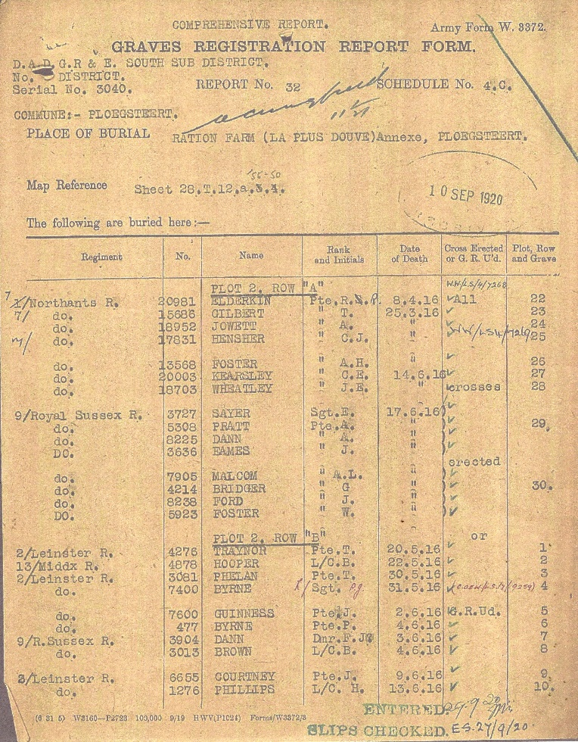

Imperial War Graves Commission
1062/1A G/4214 PRIVATE G. BRIDGER, ROYAL SUSSEX REGIMENT 17th JUNE 1916
NONE (AGE) CROSS 2 A 30.
(5TH ENTRY)
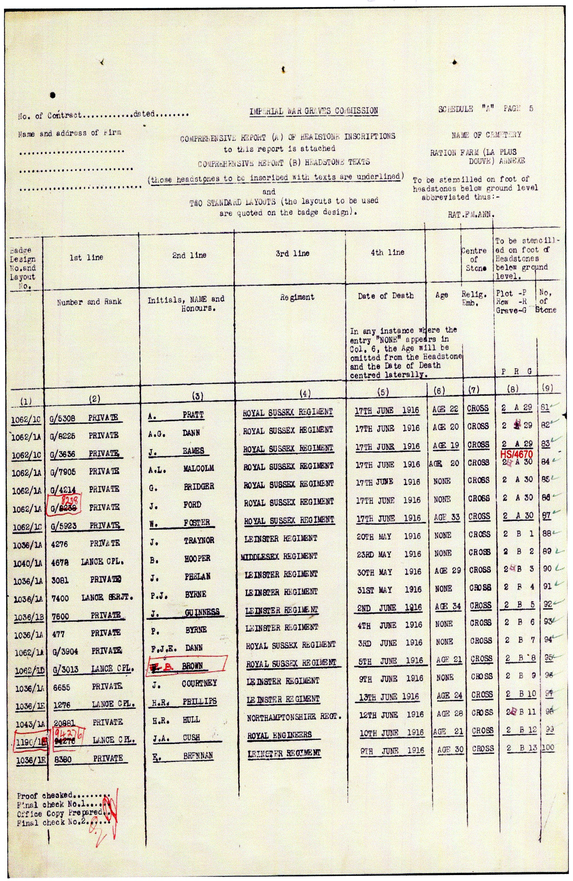

Medal index card for “John” Bridger.
The Regiment, rank, Regimental number and date of death all match George Bridger
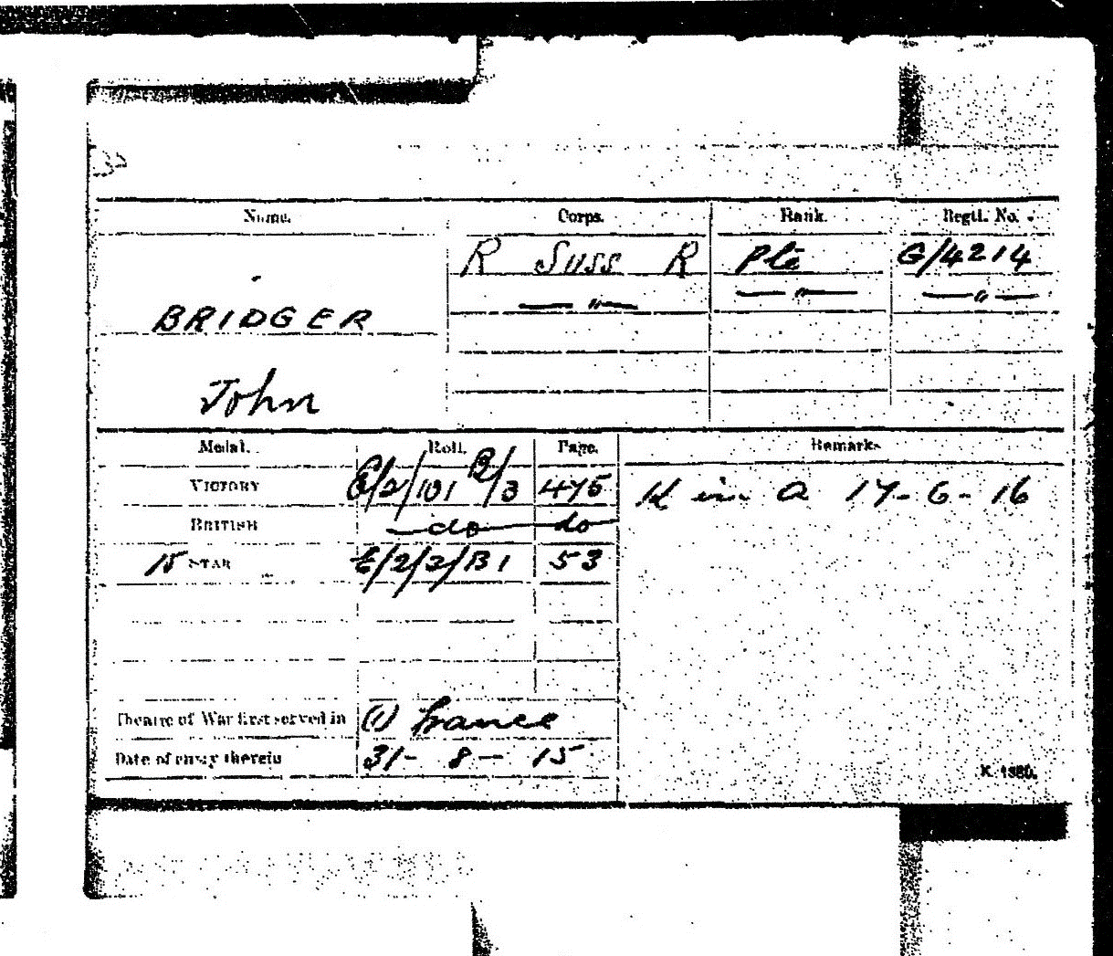

(Source T.N.A.)

Index to Ration Farm Annexe, Belgium
BRIDGER, Pte. G., G/4214 9th Bn. Royal Sussex Regt. 17th June 1916.
Son of Mrs E. Bridger, of 4, Manor Cottages, Felpham, Bognor
II. A. 30
Column 1, entry no. 10
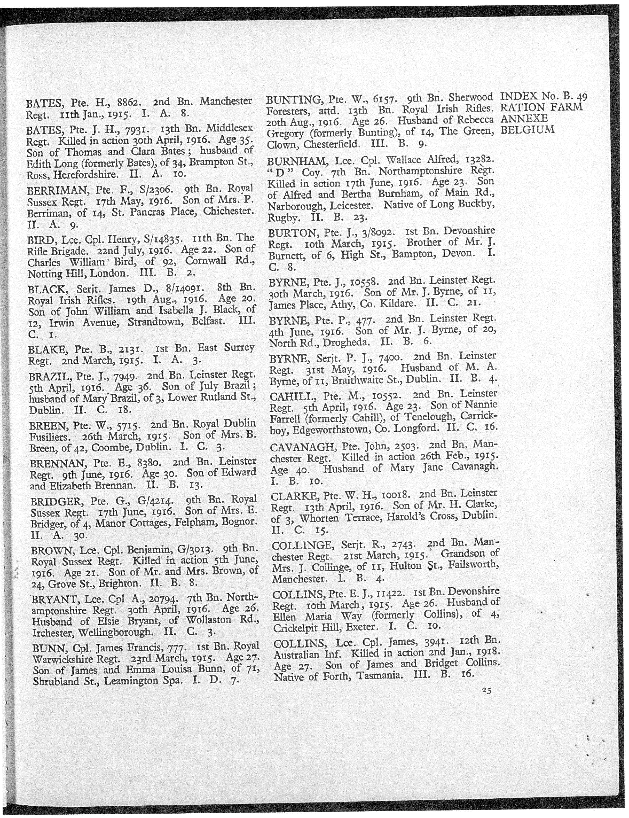

Ration Farm Annexe (La Plus Douve), Belgium

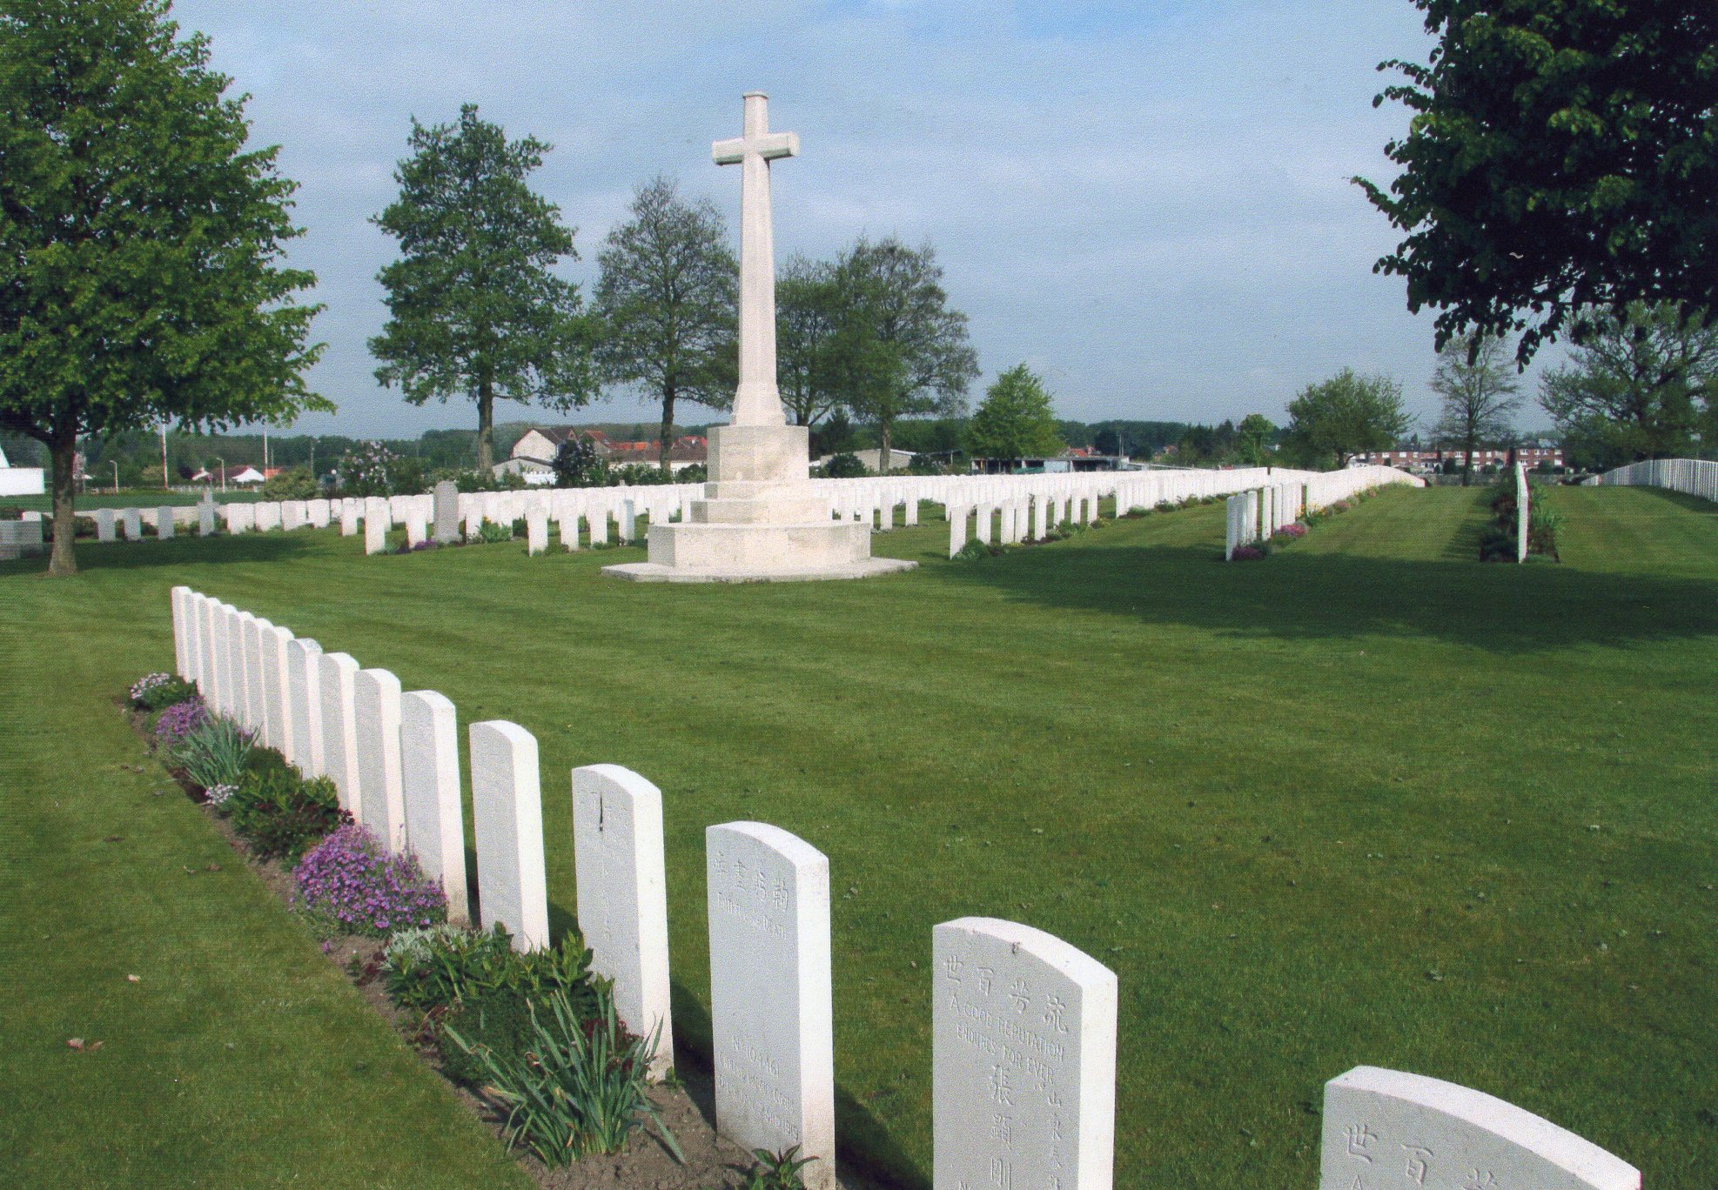

There are no records for George (Snr.) or for Edith being buried at St. Mary's Felpham. A George Bridger is shown on Free BMD as having died in the March quarter of 1914 in the Westhampnett Registration District which includes Slindon. An Edith H Bridger died in the Chichester Registration District, which also includes Slindon, in 1955 aged 86 so born about 1869.

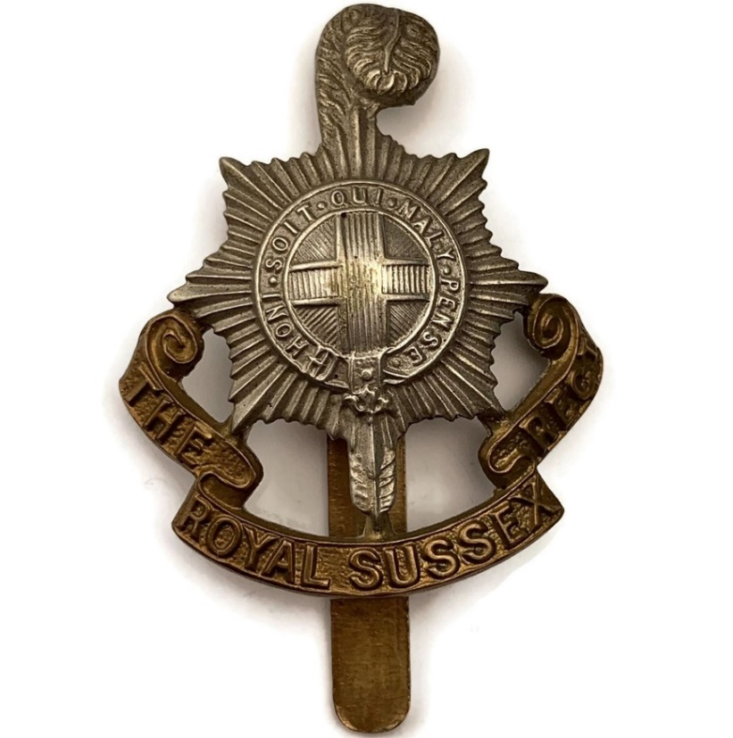

Royal British Legion
Every One Remembered - Soldier Profile G Bridger

