LINK TO COMMONWEALTH WAR GRAVES COMMISSION (C.W.G.C.)
https://www.cwgc.org/find-records/find-war-dead/casualty-details/365255/c-l-boniface/
The baptism of Charles Louis Boniface took place at St. Mary’s Felpham, on 12th July 1891. His parents were George, a Seaman, R.N. and Elizabeth.
(First entry)
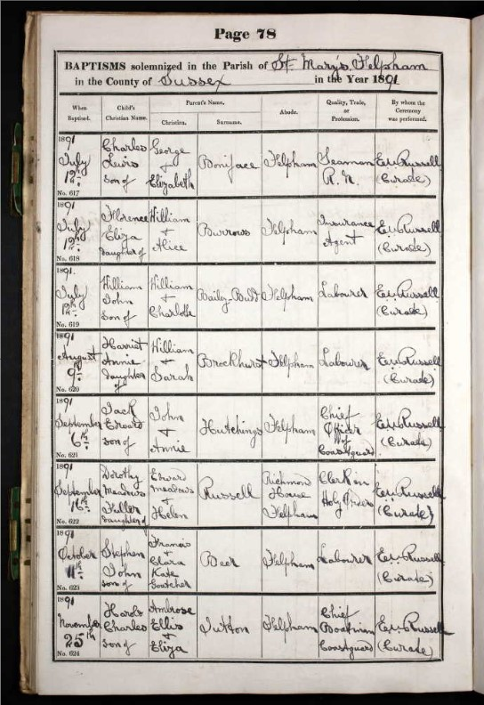
1901 census
In 1901 the Boniface family were living at Greens Cottages, Felpham. Geoge, 45, was a Bricklayers Labourer, his wife Elizabeth was 43. They had five children, William, 12, Charles, 9, Elizabeth. 7, Frederick, 5, and Clara, 3. All of the children were born in Felpham.
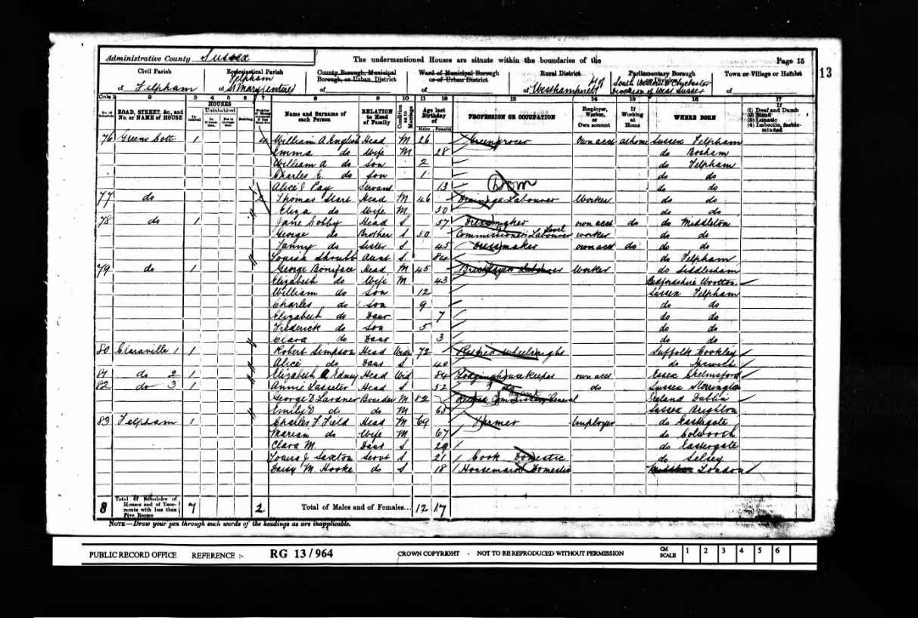

Charles Louis‘s details have not been found on the 1911 census. His Service Record shows that he was on H.M.S. “Liverpool” on that date, 2nd April, and that it was 4 days before his promotion to Stoker, 1st Class.
H.M.S. “Liverpool” was a 4,800 ton Town-class light cruiser

Charles Louis Boniface joined the Royal Navy on 12th January 1910, his engagement was for 12 years. Over the next 4 years he served on H.M. ships “Renown”, “Hermione”, and “Liverpool”. H.M.S. “Niger” was the training ship and tender for H.M.S. Vernon
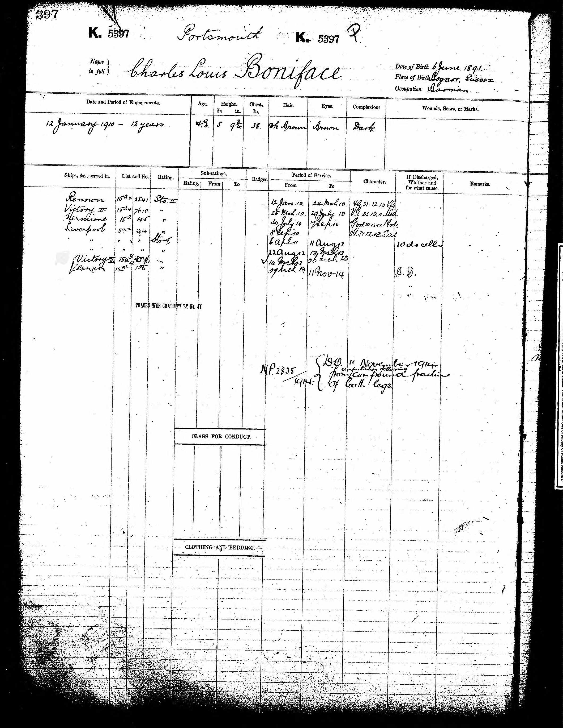
U.K. Navy Lists 1888 – 1970, Officers and Men Killed in Action.
H.M.S. “Niger” sunk 11th November 1914
* Boniface, Charles Louis, Stoker 1st Class K.5397
(2nd entry under H.M.S. “Niger” * noted as Died of Wounds
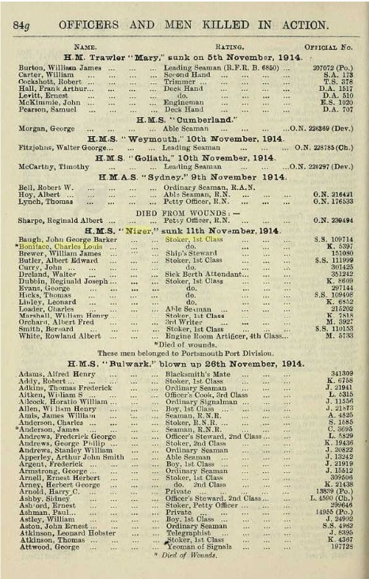

Graves Registration Report Form, Deal Cemetery, Kent
R.N., K5397/PO Boniface C. Sto. 11/11/14 (Plot) 4 (Grave (1684)
(Type of Memorial) MW (Type of Grave) C Unverified
(9th entry)

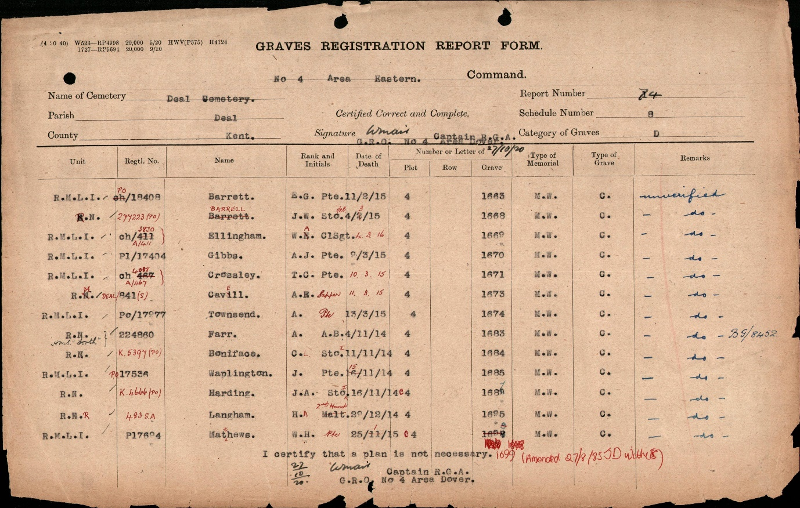

Imperial War Graves Commission
Headstone Inscriptions
NAVY 1212/1B C.L. BONIFACE STOKER 1st CLASS R.N. H.M.S. “NIGER”
11th NOVEMBER 1914 AGE 23 CROSS (PLOT) 4 (ROW) 1604 (GRAVE) 102
(12th entry)
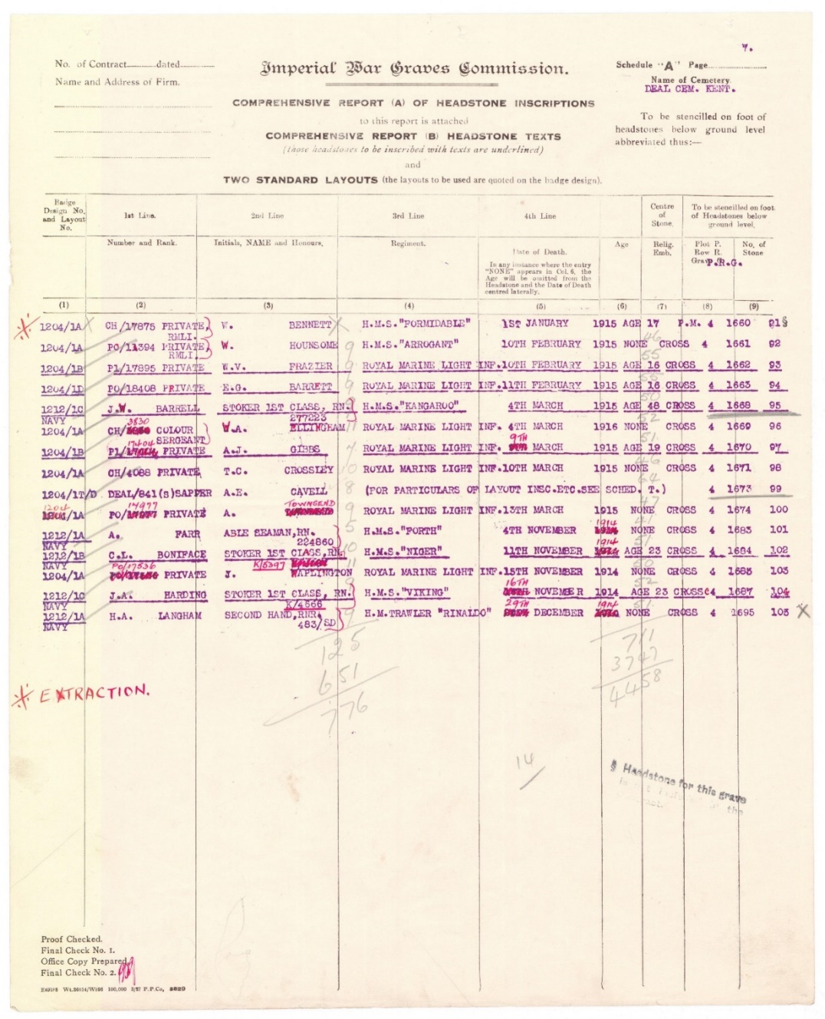

Imperial War Graves Commission
Headstone Personal Inscriptions
UNTIL THE DAY DAWNS
(Mr. G. Boniface, 1, Manor Cottages, Felpham, Bognor, Sussex)
(6th entry)
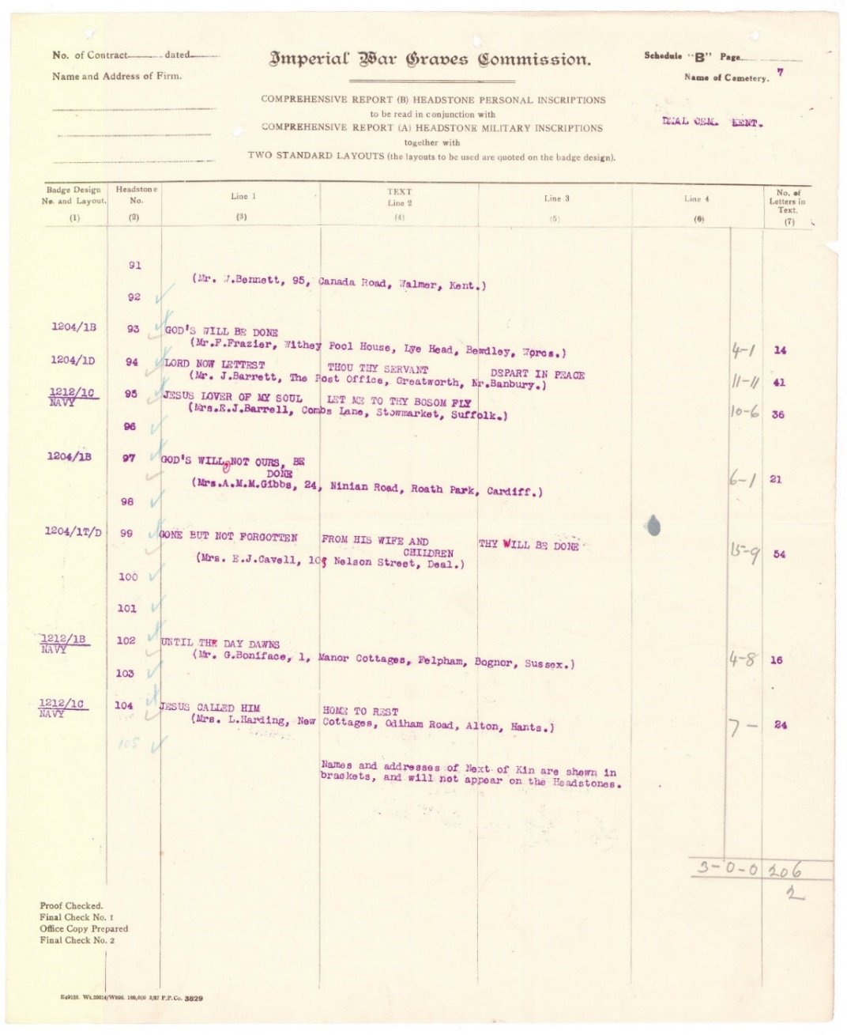

Index to Deal Cemetery Kent
BONIFACE, Sto. 1st Cl. C.L., K/5397 (PO). R.N. H.M.S, “Niger” 11th Nov., 1914.
Age 23. Son of George and Elizabeth Boniface, of 1, Manor Cottages, Felpham, Bognor. 4 1684
(5th entry 2nd column)
.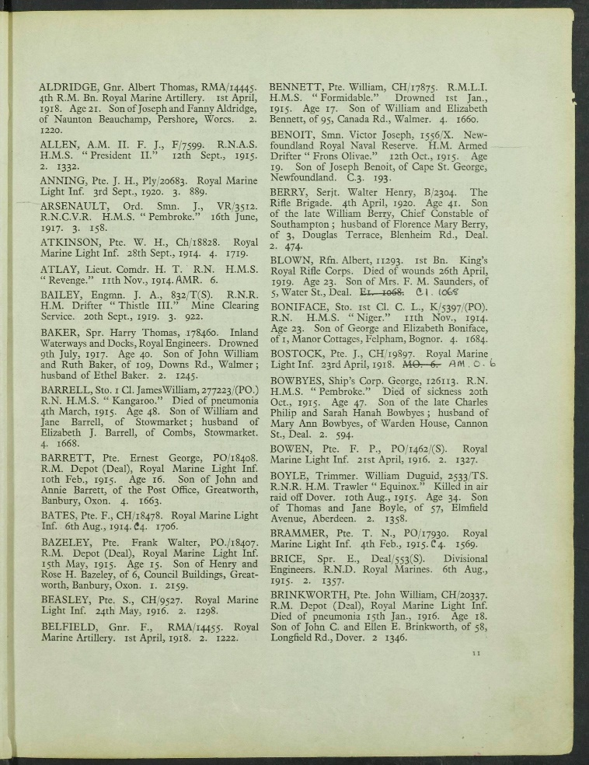

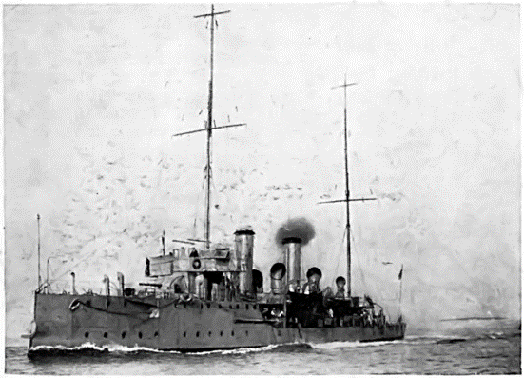
H.M.S. “Niger”

Royal British Legion
Every One Remembered - Soldier Profile C l Boniface

