LINK TO COMMONWEALTH WAR GRAVES COMMISSION (C.W.G.C.)

<https://www.cwgc.org/find-records/find-war-dead/casualty-details/1644381/gilbert-beer/>

[Jerusalem War Cemetery | Cemetery Details | CWGC](https://www.cwgc.org/visit-us/find-cemeteries-memorials/cemetery-details/71401/jerusalem-war-cemetery/)

The **1901 census** shows the Beer family, living in Felpham at Rose Lodge next to The Rectory. His father was Francis,46, a General Labourer, mother, 39, Clara K 39, born Burpham, His siblings were Constance M (13), Frank H (6) and Jack (4) with Gilbert the youngest (1)

**1911 Census**

By 1911the family was living at Clyde Villa Clyde Road.

Francis the father age 57, Clara Kate age 50, Constance Mary or May age 23 a Dressmaker, Frank Hugh’s name has been entered then deleted, Jack,14, a Printers Apprentice and Gilbert, 12, at School.

Frank Hugh, usually Hugh Frank, would have been 16 but has not yet been found.

By 1911 three of the seven children of the family had died.

**WW1 Medal Rolls Index card**

BEER Gilbert R.Suss.R. Pte 4/2053 later 200421

Entitlement Victory & British Medals and (19) 15 Star

Died 26-2-17

Theatre of War served in Balkans. Date of entry therein 8-8-15

**Index to Jerusalem Memorial**

BEER, Pte. Gilbert, TF/200421 4th Bn. Royal Sussex Regt.26th March 1917

(Column two, 6th entry)

**The Jerusalem War Cemetery**

(Text and photograph from Wikipedia)

The Jerusalem War Cemetery is a British cemetery in [Jerusalem](https://en.wikipedia.org/wiki/Jerusalem) for fallen servicemen of the [British Commonwealth](https://en.wikipedia.org/wiki/British_Commonwealth) in the [World War I](https://en.wikipedia.org/wiki/World_War_I) in the [Palestine campaign](https://en.wikipedia.org/wiki/Sinai_and_Palestine_campaign).

The main cemetery is located on [Mount Scopus](https://en.wikipedia.org/wiki/Mount_Scopus) next to the [Hadassah hospital](https://en.wikipedia.org/wiki/Hadassah_Medical_Center#Mount_Scopus_campus) and the [Hebrew University of Jerusalem](https://en.wikipedia.org/wiki/Hebrew_University_of_Jerusalem) campus, 4.5 km north of the [Old City of Jerusalem](https://en.wikipedia.org/wiki/Old_City_of_Jerusalem).[[1]](https://en.wikipedia.org/wiki/Jerusalem_British_war_cemetery#cite_note-cwgc-1)

The cemetery contains the graves of 2,515 Commonwealth service personnel (including 100 unidentified), a number of whom were removed from at least seven other cemeteries in the area where they could not be maintained. A small Jewish section is near Plot 'N'. Units from Australia, New Zealand, India, Egypt, South Africa and the British West Indies are also represented besides those of the United Kingdom. A small number of German and Turkish dead also are buried at the cemetery.

Notable burials include Major [Philip Glazebrook](https://en.wikipedia.org/wiki/Philip_Glazebrook), British [Conservative](https://en.wikipedia.org/wiki/Conservative_Party_(UK)) [member of parliament](https://en.wikipedia.org/wiki/Member_of_parliament).

The cemetery also contains the Jerusalem Memorial to 3,300 Commonwealth service personnel who died on operations in the same war in Egypt and Palestine and have no known grave. Its architect was [John James Burnet](https://en.wikipedia.org/wiki/John_James_Burnet) and the sculptor [Gilbert Bayes](https://en.wikipedia.org/wiki/Gilbert_Bayes). It was unveiled on 7 May 1927 by [Lord Allenby](https://en.wikipedia.org/wiki/Edmund_Allenby,_1st_Viscount_Allenby), who had been British commander-in-chief in the Middle East. The memorial incorporates a chapel with a mosaic that was designed by [Robert Anning Bell](https://en.wikipedia.org/wiki/Robert_Anning_Bell).

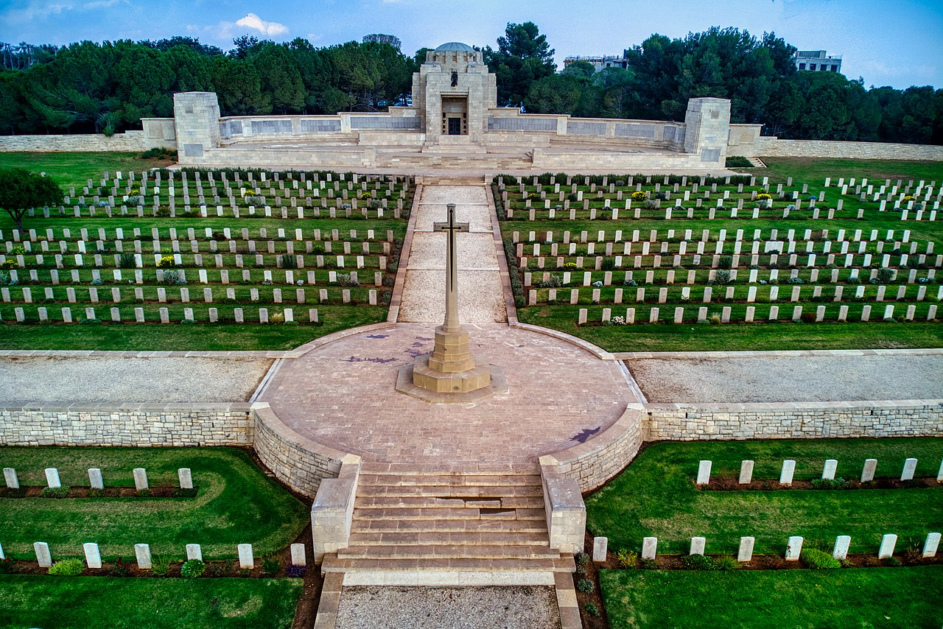

Royal British Legion

[Every One Remembered - Soldier Profile Gilbert Beer](https://everyoneremembered.org/profiles/soldier/1644381/)

