LINK TO COMMONWEALTH WAR GRAVES COMMISSION (C.W.G.C.)
Private William Charles Baxter | War Casualty Details 165878 | CWGC

William Charles’s gravemarker at Chocques Military Cemetery,
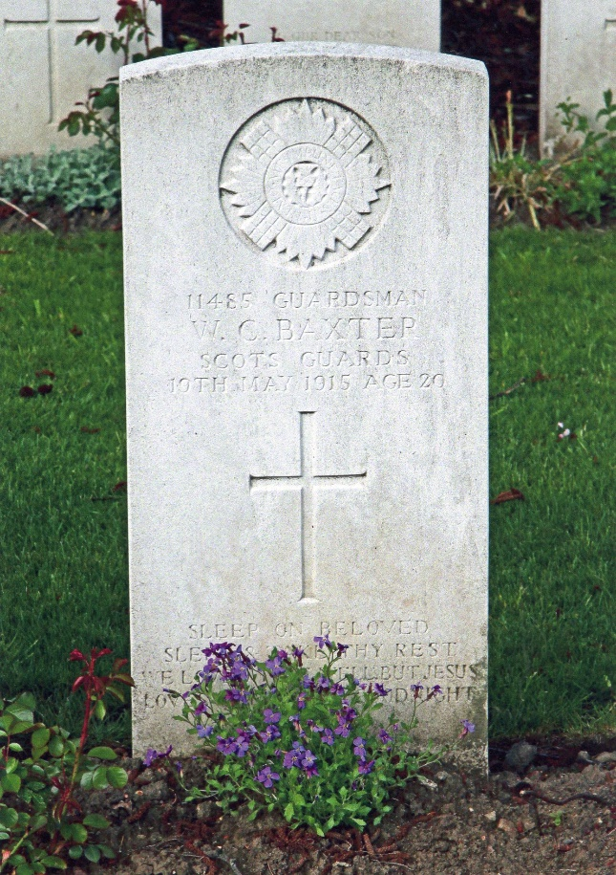

William Charles Baxter was born in 1894 in Thurso, Caithness, Scotland the most northerly town on the British mainland.

His father, William, born in Peckham, London, in 1871 had married Charles (sic) Ann Mcgowan, also born in 1871, at Knockandu, Morayshire. William was a Chief Officer with H.M. Coastguards.

William had one older brother, 3 younger brothers and a younger sister, Dorothy, all of whom were born in Scotland.

In 1901 William & Charles (sic) were resident in the civil parish of Bervie, Caithness.

By 1911 William Charles appears on the England census resident with Emily Gilford a widow in Peckham, where his father was born, with her daughters. He was described as a Nephew, age 16, Single, (working in a) Laundry, born Thurso, Caithness, (Visitor). Emily was probably the widow of James Gilford, they had married in Camberwell in 1873 and had daughters Florence May and Ethel Jessie.

1911 census

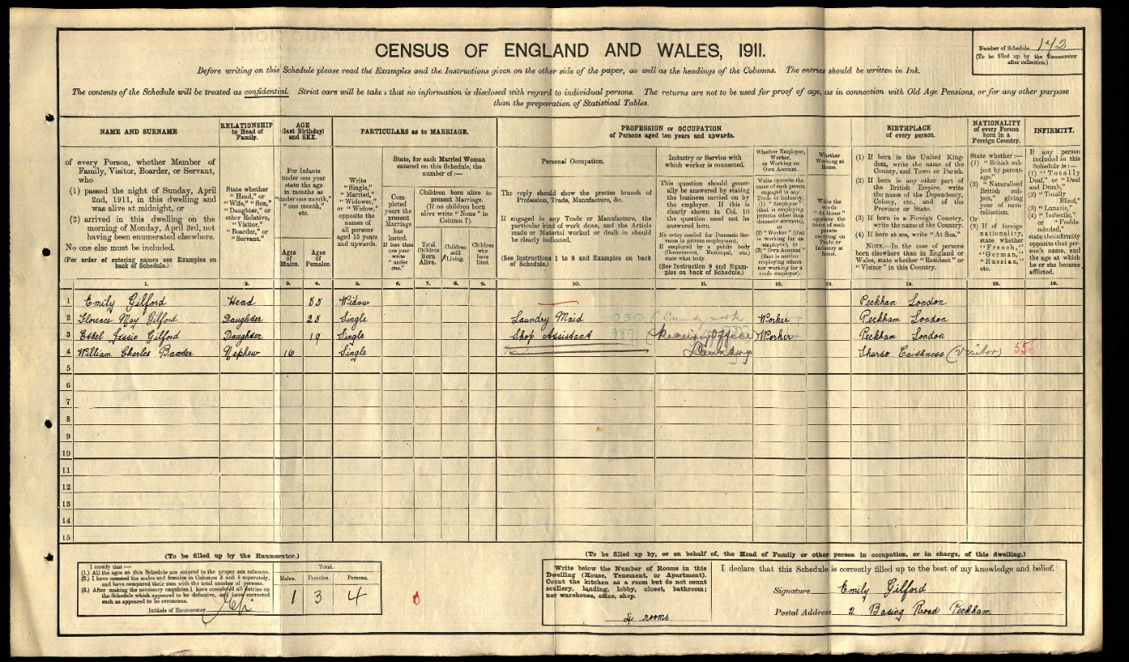

Chief Officer Baxter was appointed to Felpham Station on 17th March 1912 and the family that included James born 1893, Herbert born 1897 and Arthur born in 1900 were living at Felpham when war was declared. Felpham Coastguard Station was closed in the 1920's.

On 3rd October 1914 William enlisted in either the 1st or 2nd Battalion of the Scots Guards, there are conflicting records, and served with the British Expeditionary Force (B.E.F.) from 16th April 1915.
His attestation documents are on Findmypast but the details are not clear.

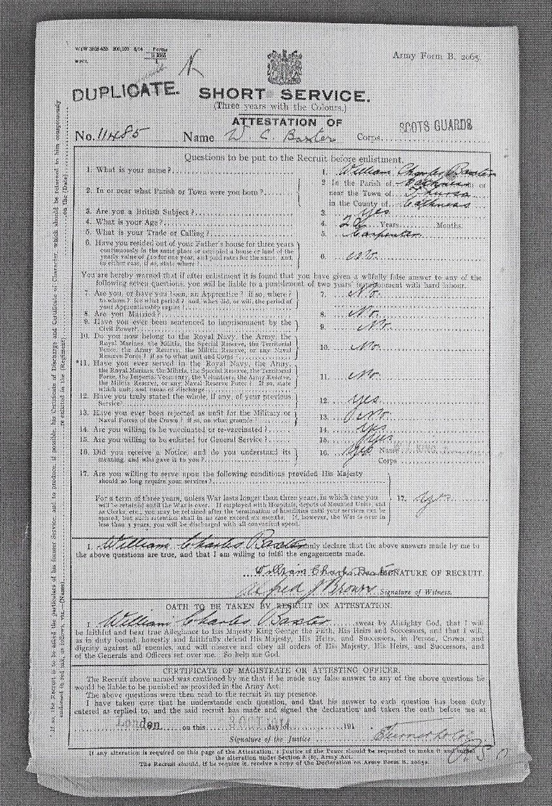

11485 Private William Charles Baxter died at the 1st Casualty Clearing Station at Chocques on 19th May 1915, at the age of 20, and is buried in Chocques Military cemetery, France ref: I C 35. He had only been in France for 34 days.

May 1st Gonnchem
Fighting strength CO and Adj 16 Coy Office 862 Other ranks,exclusive of 29 machine-gunners ,21 Signallers and Orderlies,
13 Pioneers, 5 Snipers and 4 Trench-mortar men available for trenches.
2nd Paraded at 4.30 p.m. to relieve 5th Sussex in D3. Rue du Bois. Route W 13 D Y of Lannoy Pont Levis -Locon Lacouture and Windy Corner. Arrived Windy Corner at 8 p.m.
3rd During the morning the Germans shelled the support trenches considerably and also put several bombs into the front trenches. We bombarded their trenches with 6" and 9.2" for about 20 mins. Line now held. D3 runs from the Cinder track backwards about 450 yards. Very good breastworks with good parados.
4th Trenches D3. Very Quiet. Think a German relief was carried out last night as new lot (?) very quiet. Germans shelled Rue du Bois in the afternoon. No damage. Relieved by Coldstream’s beginning at 9.15 p.m. completed 11.30. We have to find fatigue party of 3 Officers and 300 men. "B" company billets the night at Richebourg.
Total casualties 2 Killed 12 Wounded
Graves Registration Report Form:-
1/Scots Guadds (sic) 11485 BAXTER Pte. W.
Date of Death 20.5.16 Plot, Row and Grave C 36
William Charles entry is 5th from the bottom of the page
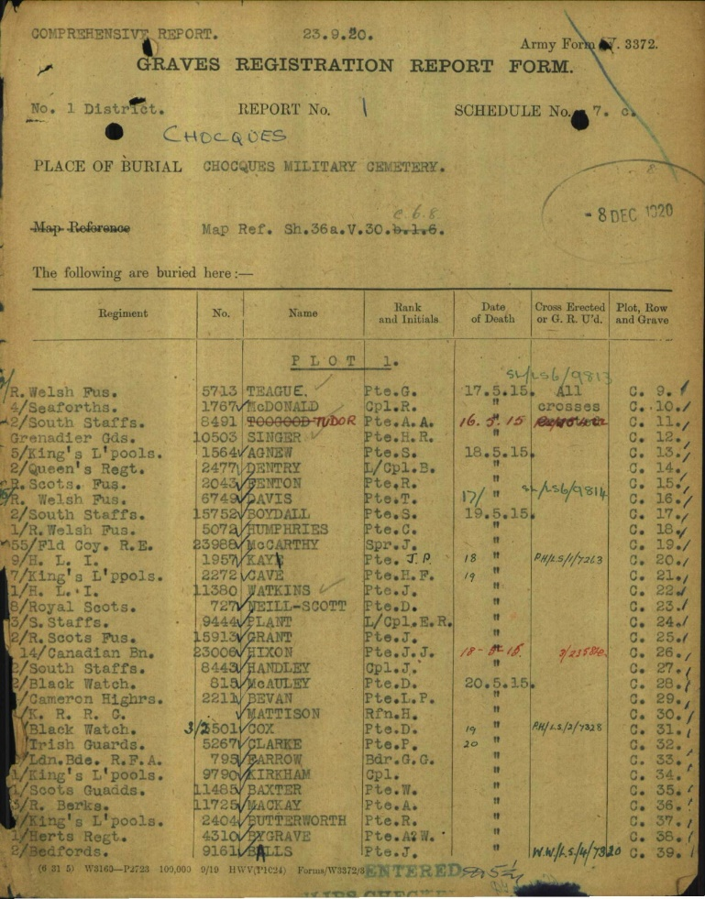

Headstone Inscription
IMPERIAL WAR GRAVES COMISSION
11435, GUARDSMAN, W.C.BAXTER, SCOTS GUARDS,
19th May 1915, AGE 20, CROSS, IC 35, 186
(6th entry)
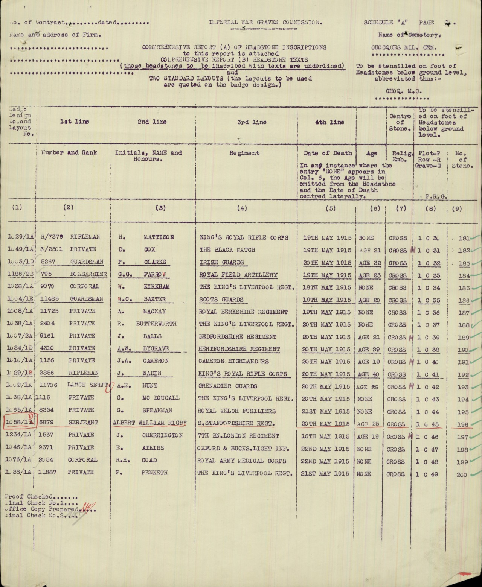
(Source T.N.A.)

Personal Headstone Inscription
IMPERIAL WAR GRAVES COMISSION
1004 /1E/186
SLEEP ON BELOVED, SLEEP AND TAKE THEY REST, WE LOVED THEE WELL BUT JESUS LOVES THEE BEST
GOODNIGHT
Mrs, C.A. Baxter, “Bruntlands”, The Grove, Felpham Nr, Bognor
(6th entry)
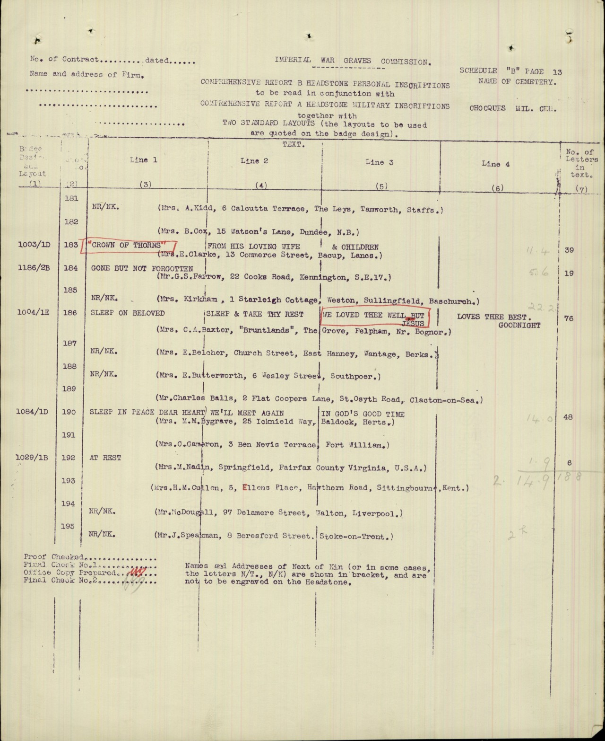
(Source T.N.A.)

Register of Soldiers Effects:-

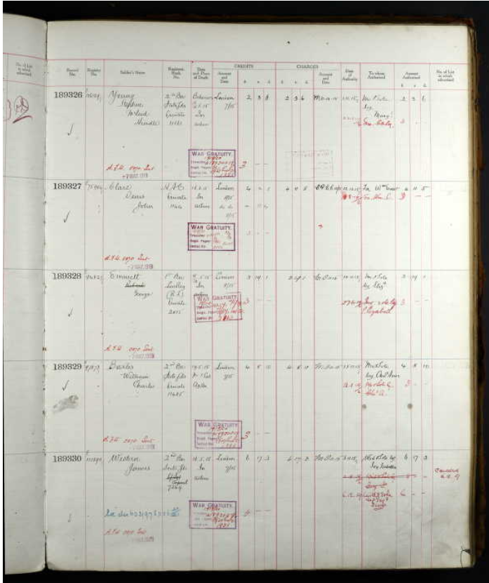

William’s credits amounted to £4.8s.10d plus £3.0s.0d War Gratuity left to his Mother Chas (sic) Ann.

More than 16,000 casualties were sustained in the attack at Festubert, in support of the much larger French offensive to the South at Vimy Ridge. French losses there were over 102,000, against German almost 50,000, including those at Festubert.

De Ruvigny’s Roll of Honour

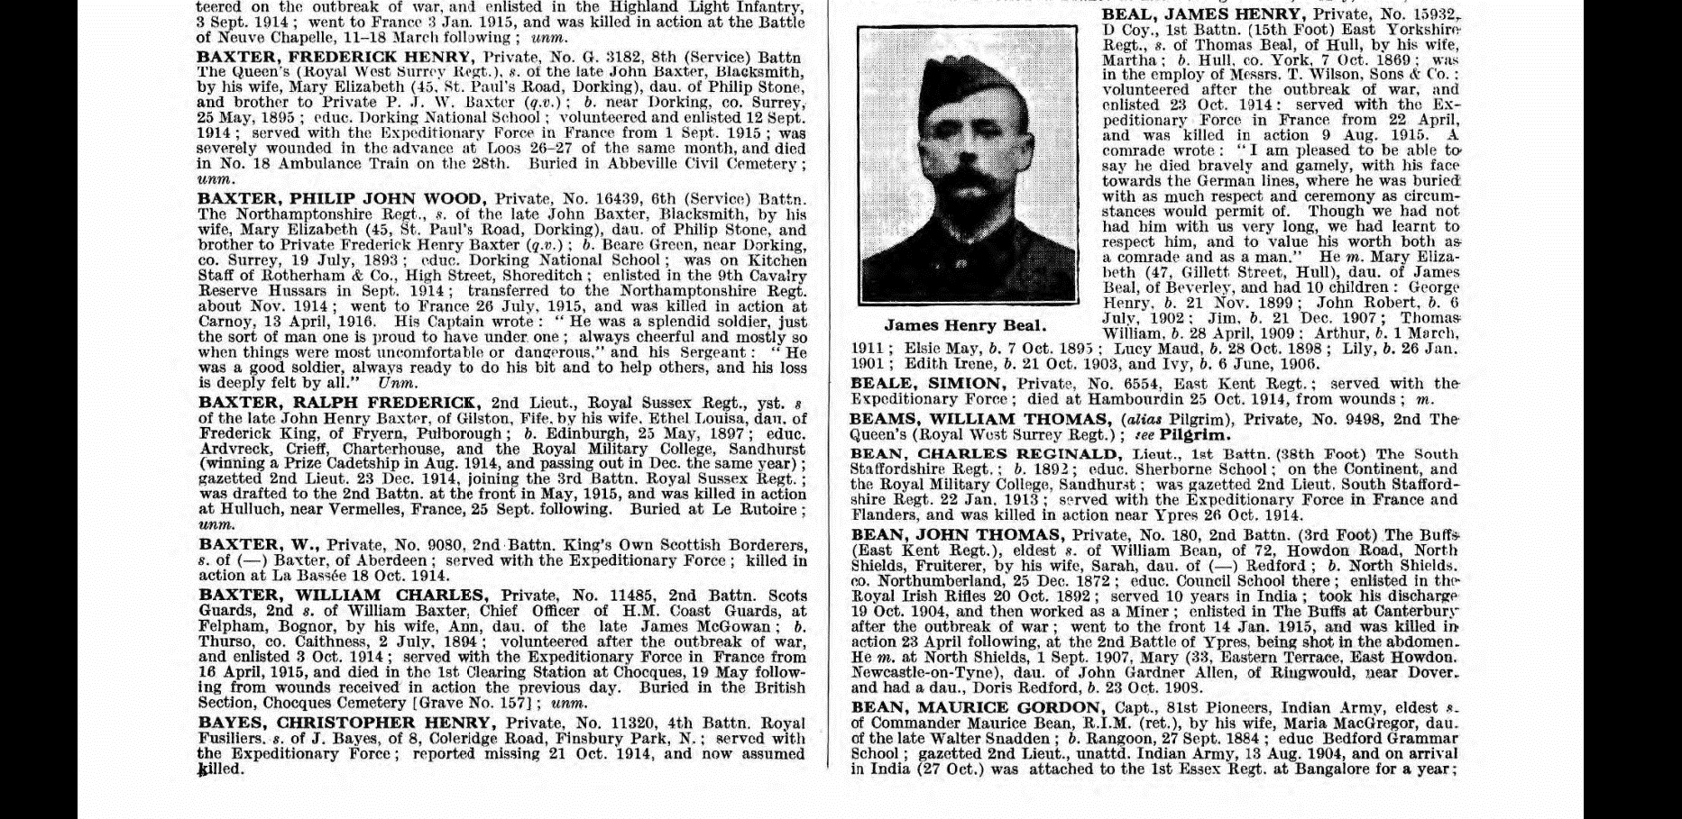

BAXTER, WILLIAM CHARLES, Private, No. 11485, 2nd Battn., Scots Guards, 2nd s. of William Baxter, Chief Officer of H.M. Coast Guards, at Felpham. Bognor, by his wife, Ann, dau.. of the late James McGowan: b. Thurso, co, Caithness, 2 July, 1894; volunteered after the outbreak of war, and enlisted 3 October 1914; served with The Expeditionary Force in France from 16 April, and died in the 1st Clearing Station at Chocques, 19 May following from wounds received in action the previous day. Buried in the British Section, Chocques Cemetery (Grave No. 157); unm.

Index to Chocques Military Cemetery

BAXTER, Pte. William Charles, 11485.1st Bn. Scots Guards. Died of wounds 19th May 1915. Age 20. Son of W. and C.A. Baxter, of “Bruntlands” The Grove, Felpham, Bognor, Sussex.
I.C.35 (Column 1 entry 7)

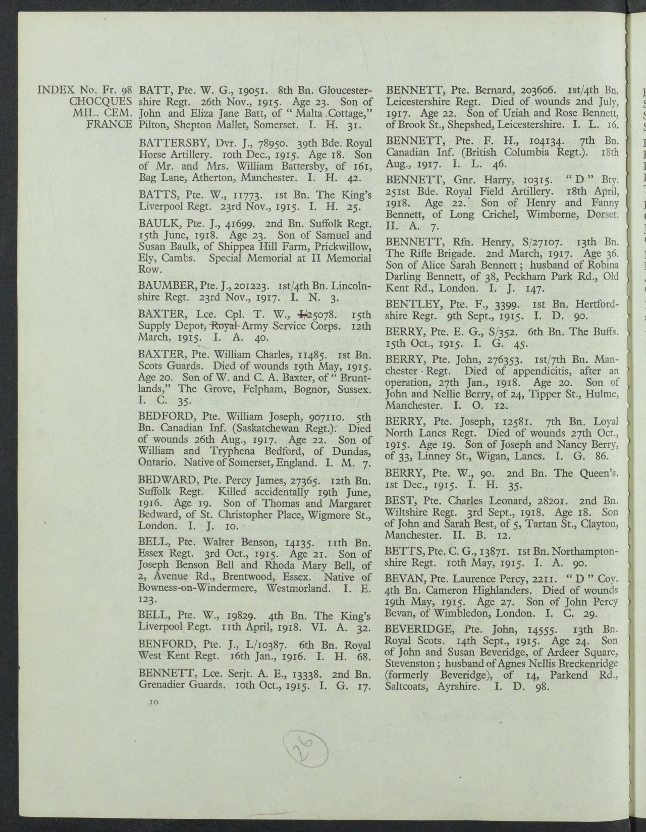

William's address is given as "Bruntlands" The Grove, Felpham.
Kelly's Directory for the 1950's shows ” Bruntlands” as number 8.
According to the Ordnance Survey Bruntlands is a hamlet in Moray, Scotland.
It is some 140 miles from Thurso, Caithness where William Charles was born.
Perhaps at some time a holiday resort for the family
British Army medal index cards 1914-1920
Campaign 1914-15
Baxter William Charles Scots Guards Pte. 11485 (top left hand entry)
Entitled to Victory, British medals & 1915 star. D.of W.
Theatre of War France, Qualifying date 16.4.15
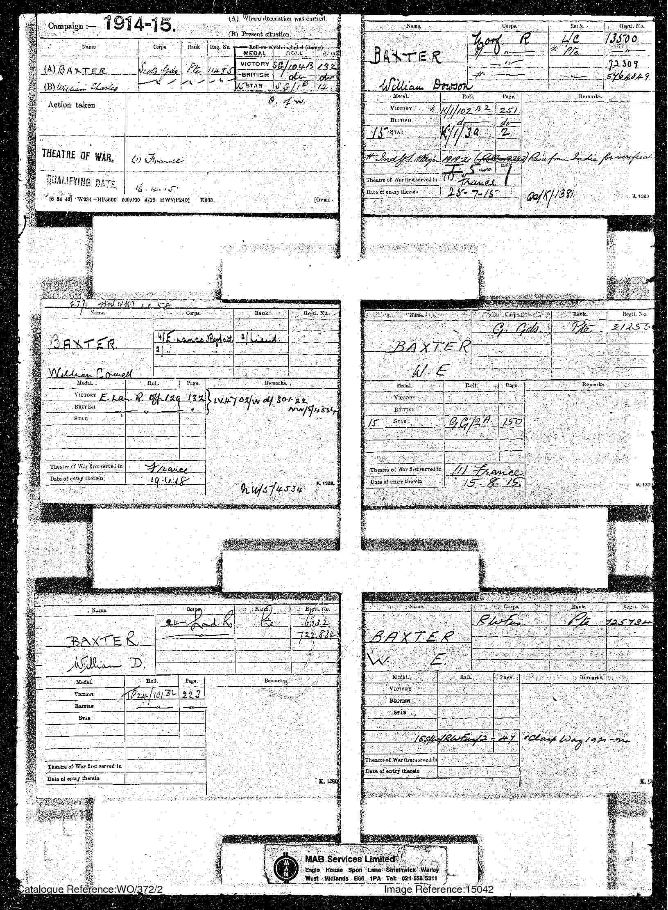
(Source T.N.A.)

Chocques Military Cemetery
Pas de Calais, France, ref. I C 35
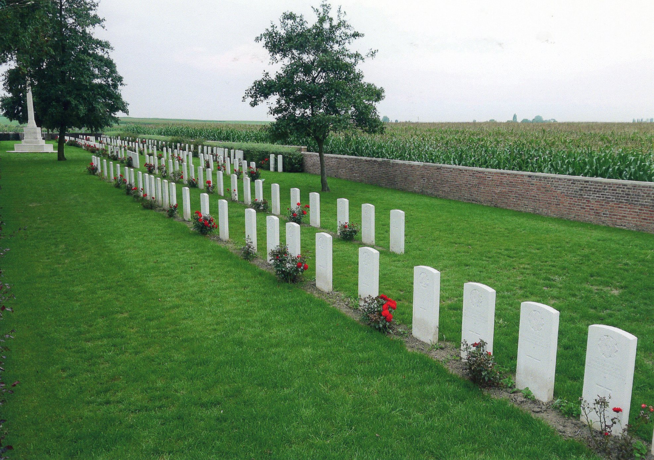

William Baxter died age 80 in 1943 and Charles (sic) in 1946 age 74. They are both buried in St. Mary's churchyard ref: F129. The grave is described as a rectangular kerbstone with four corner posts.

Some years ago the author found in our garden a brass nameplate for

"W BAXTER

COASTGUARD".

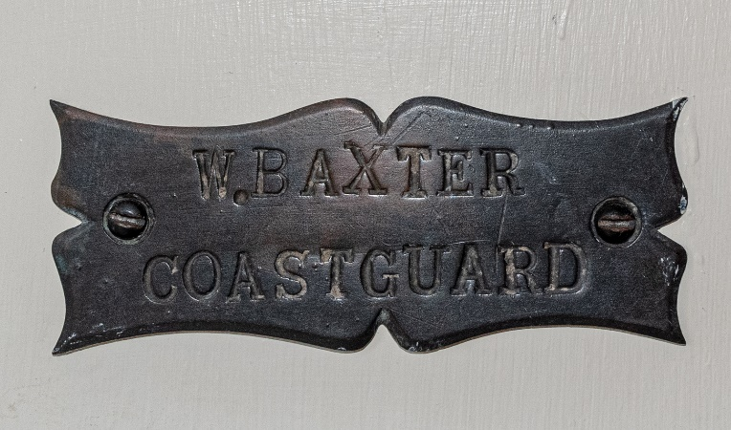

How did it get to the Roundle Estate from Coastguard House?

Every One Remembered - Soldier Profile William charles Baxter

