Felpham is unique in that it has a memorial in the form of the Felpham and Middleton Memorial cottages. These were two semi-detached cottages, now detached, built just after what became known as the Great War, for the family or descendants of local casualties. A plaque inside the cottages gives the names of 39 of the casualties.
The memorial in St. Mary’s also has 39 names but in each memorial two names are different from the other giving a total of 41.
To commemorate the 1918 Armistice the History, Heritage & Archive Group selected 17 of the 41 whose names appear on the two Felpham memorials for detailed research. One further casualty was included whose name appears on his parents’ memorial in St. Mary’s churchyard.
The following paragraph explains why some or all details of some men’s service cannot be found.
From The National Archives reference WO363
“In September 1940, as the result of a fire caused by an incendiary bomb at the War Office Record Store in Arnside Street, London, approximately two thirds of 6.5 million soldiers' documents for the First World War were destroyed. Those records which survived were mostly charred or water damaged and unfit for consultation and became known as the 'burnt documents”.
During the 2018 Remembrance weekend the Felpham Village Conservation Society held a Lyons Corner House type tea party in Felpham Memorial Village Hall followed on the Sunday by the Remembrance Day service and a walk through the village showing, where possible, the homes of some of the 18 and each man’s story.
The members of the Group, from the left, Roger Brooks, Group leader Joyce Pritchard, Marion Brooks, Wendy Elsden, Keith Hellyer, Sue Tressler, Lorraine Stevens.
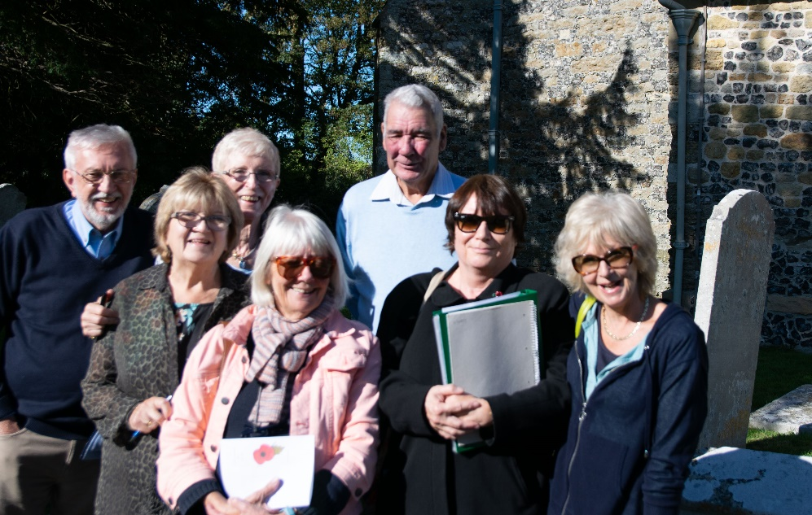
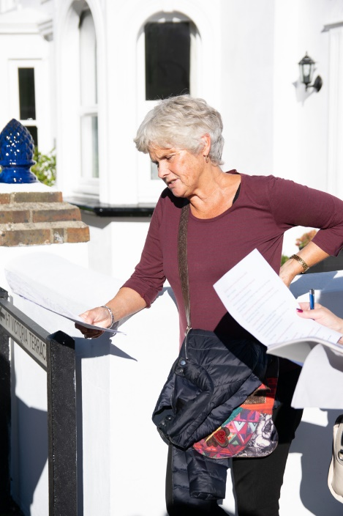
Group member and photographer of the Group Angela Barnes, taken whilst on the Remembrance weekend tour of the village
In 2021, a member of the original group carried out further research on all 41 of those whose names appear on the two memorials. The intention being to establish what the connection was, if any, between each individual casualty and Felpham.
During that subsequent research it became apparent that there were several casualties of the Great War who had some connection with Felpham but are not recognised as such.
The Group was re-established in early 2023 and in 2024 was re-named The Felpham History Group. It is the intention of the Group that all the names on the two memorials are included on the Groups’ website.
The Felpham History Group (felphamhistorysociety.net)
If you have any information about any of Felpham’s Fallen please do contact the Group.

