CYRIL JACKSON

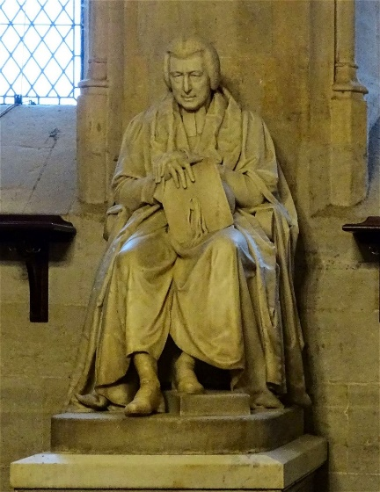  
COMMEMORATIVE BLUE PLAQUE APPLICATION

Compiled by Kevin Watson

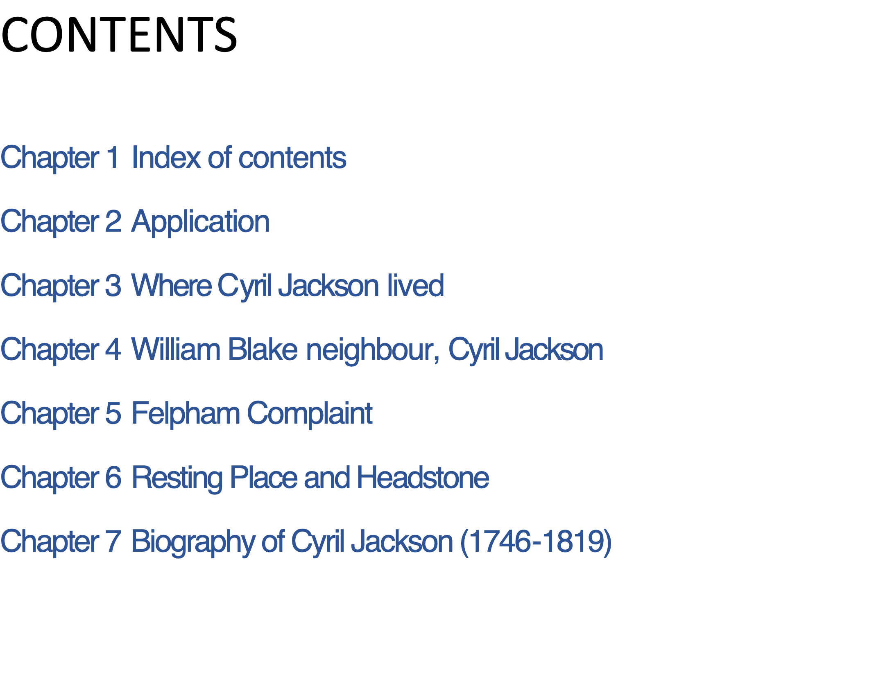

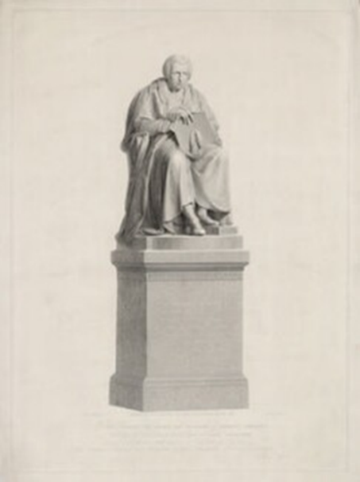

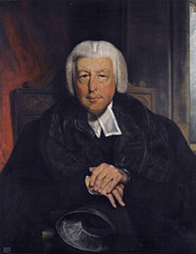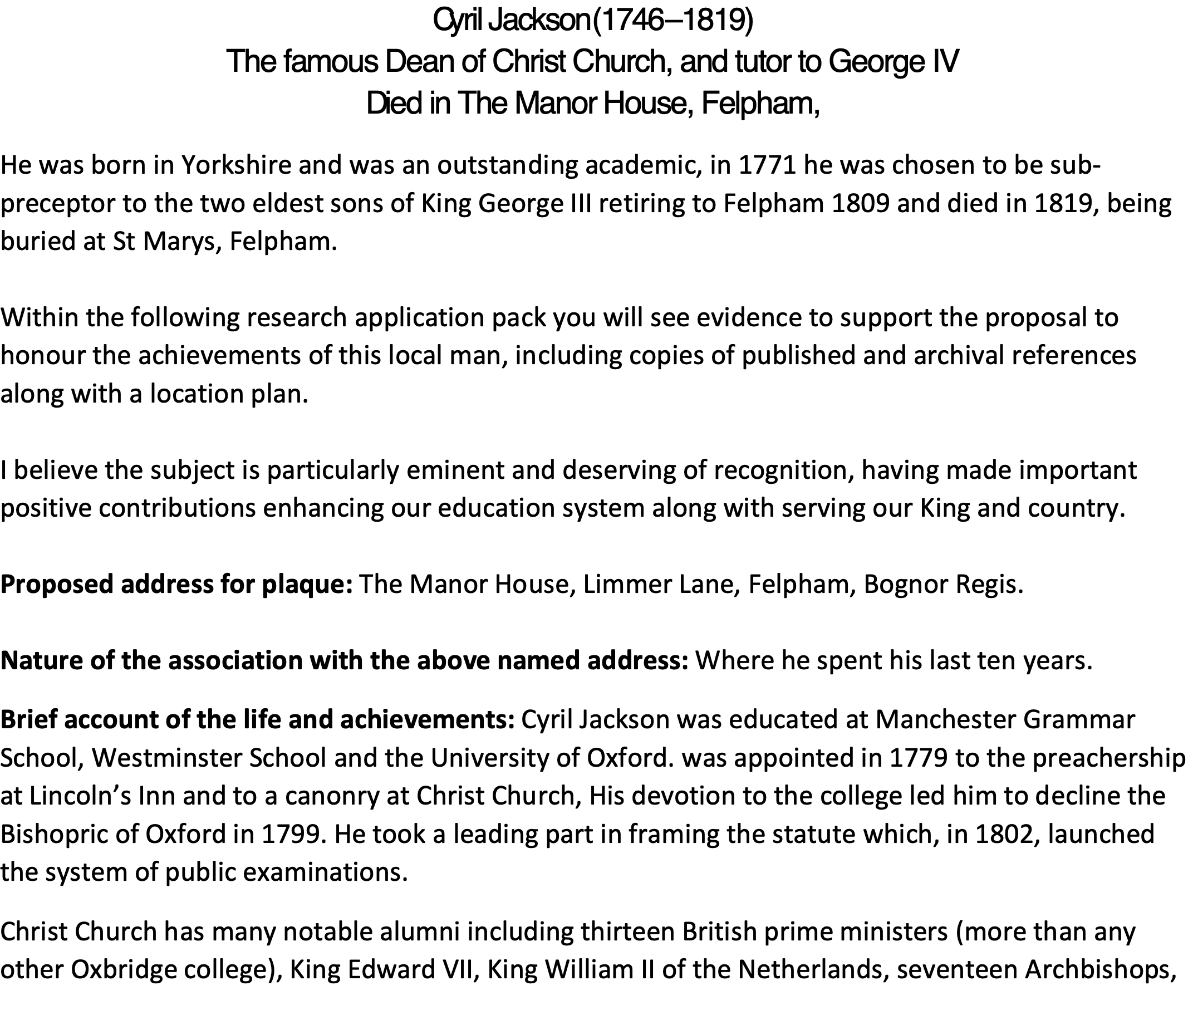

Cyril Jackson lived in The Manor House, Limmer Lane, Felpham, Bognor Regis.   
The Manor House still exists today within Felpham Village.  
  
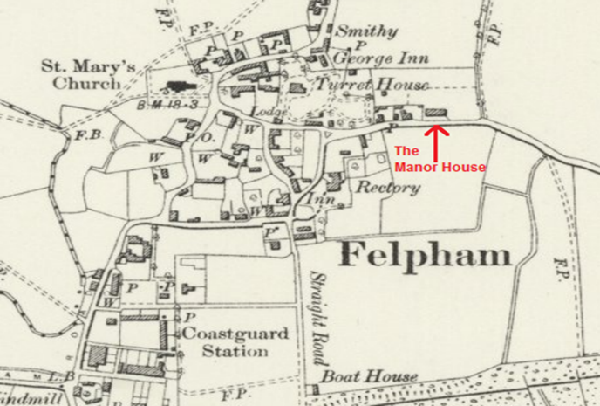

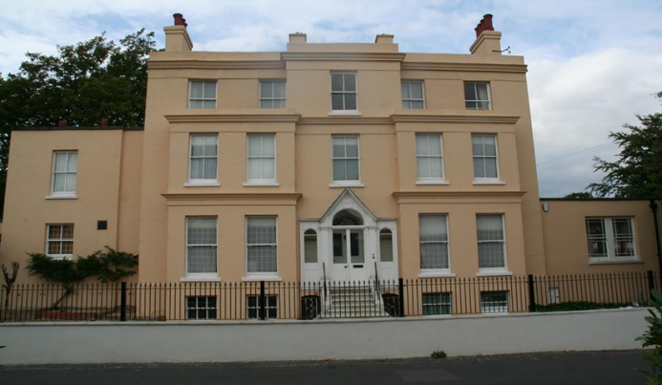  
  
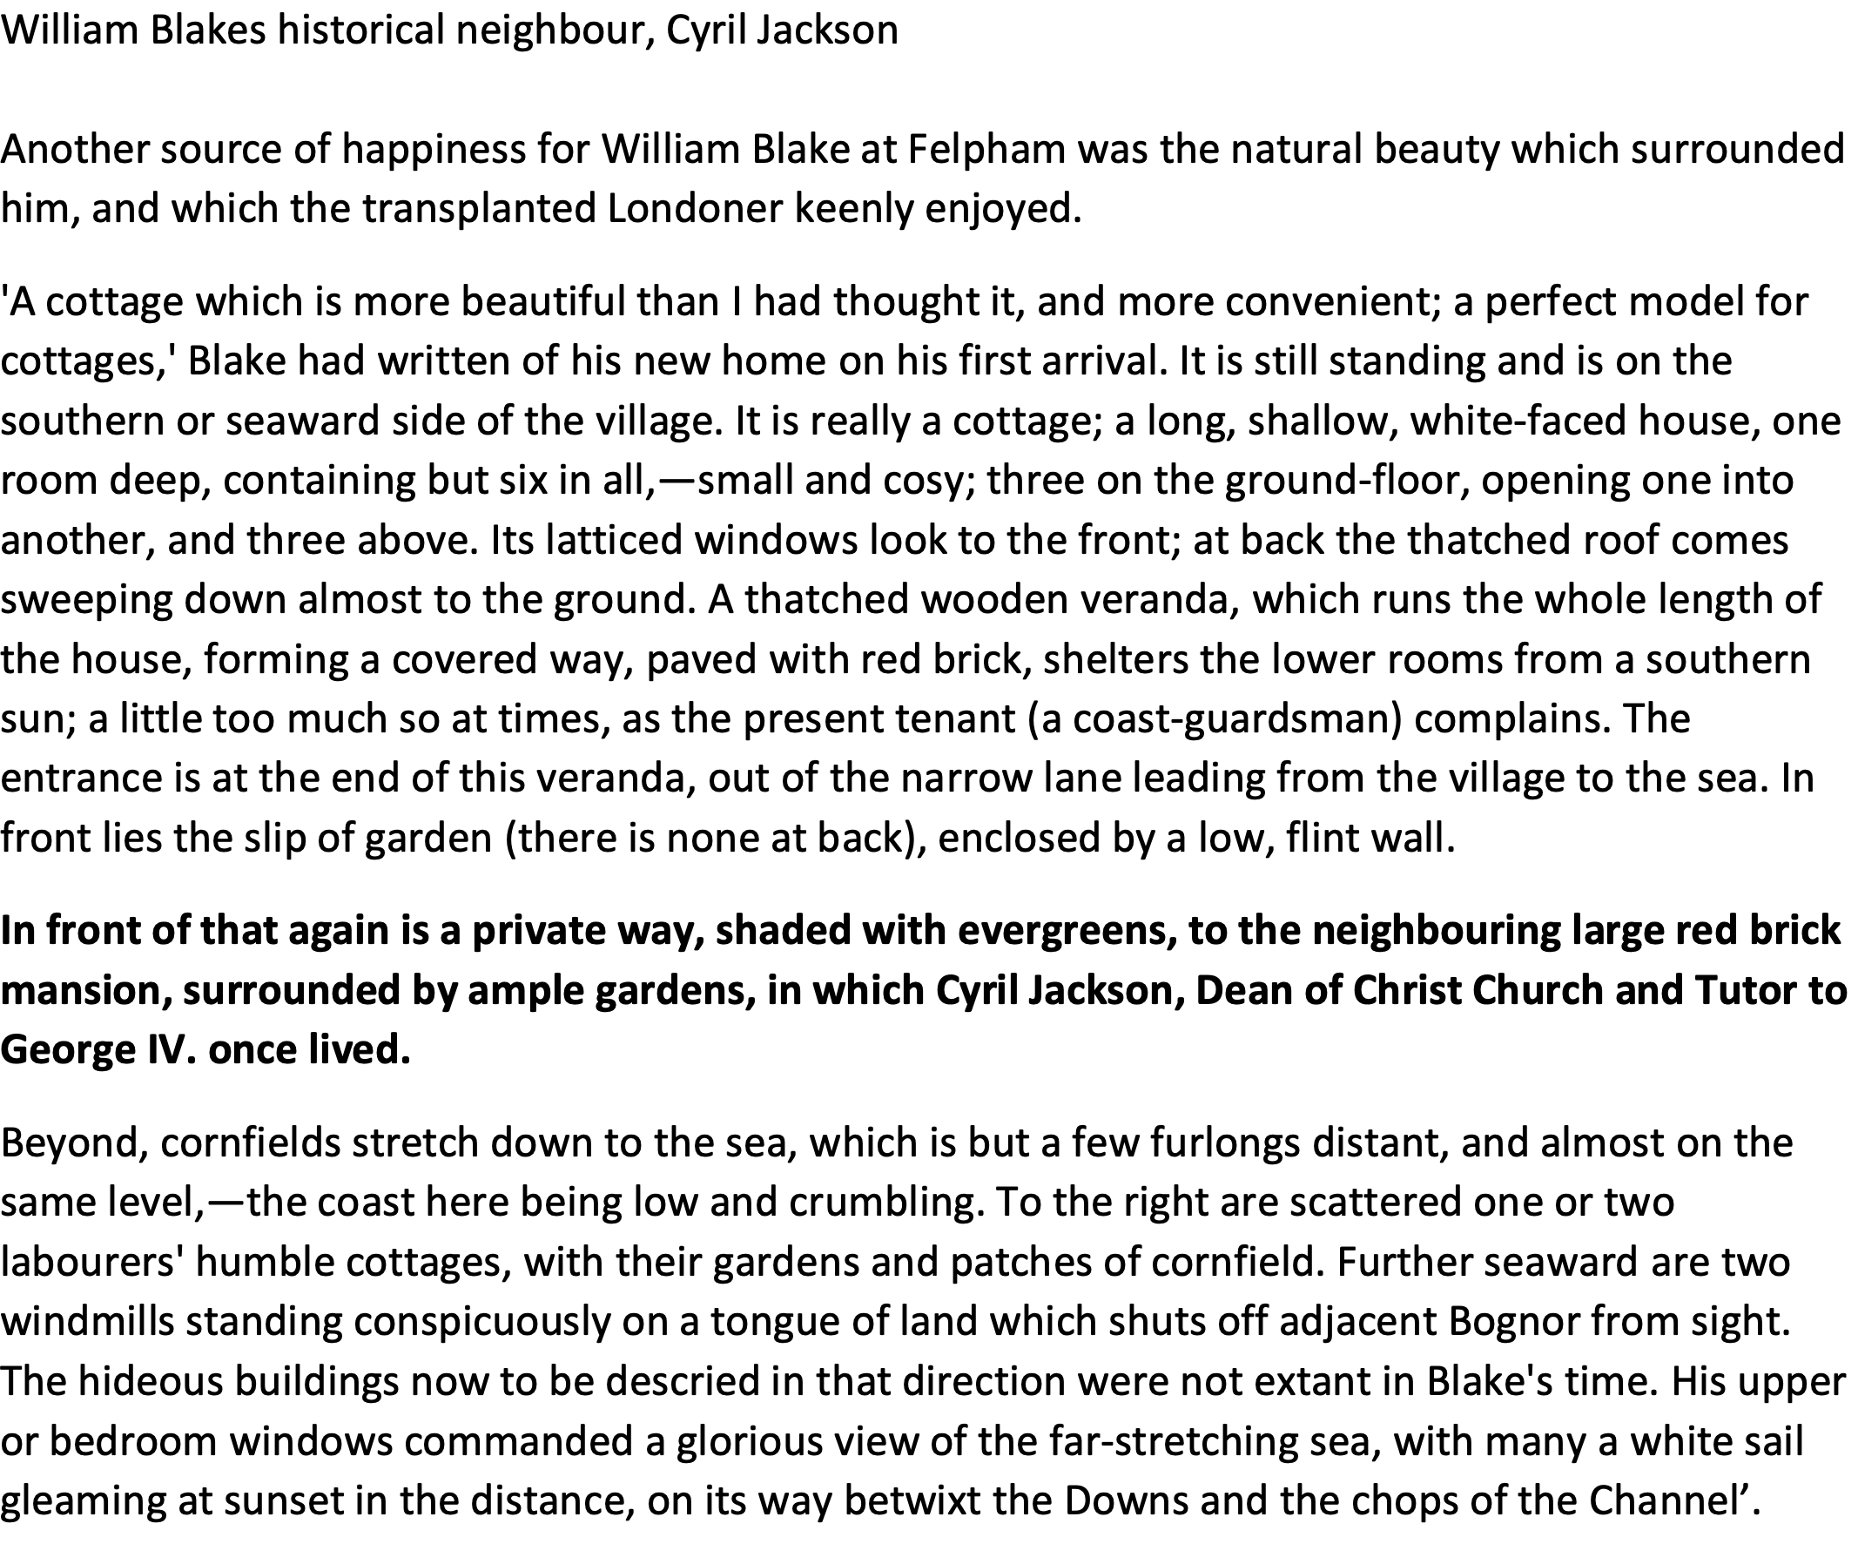  
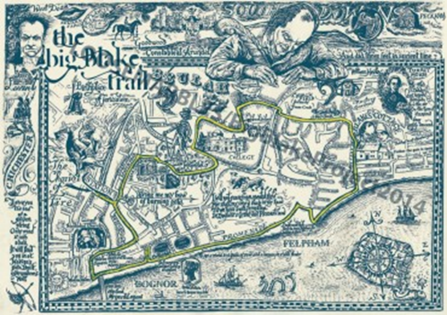

Complaining to the King about the quality of stationery available in the village.   
  
This is a thank you letter that I have that was written to King George IV just a few months prior to Cyril Jacksons death, it has been rumoured that the King did visit Cyril in Felpham, shortly after this letter, but I have been unable to verify this  
 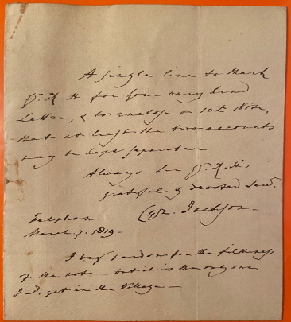 *A single line to thank George for your very kind letter and for enclosing a £10 note, that at # for the two accounts may to last #*

*Always for George Grateful and devoted servant Cyril Jackson****Felpham******March 3 1819******I beg pardon for the # of the letter and but it is the only one I could get in the village*** *# unsure what these words are*

